6 - Topbar
Topbar Introduction 10
Header Right Click menu 10
Collapse Menus 10
Hide Editortype Menu 10
File Menu 10
New 11
Open 12
Open Recent 12
Revert 12
Recover last Session 12
Recover Autosave 12
Save 12
Save As 12
Save Copy 12
Link 12
Append 12
Data Previews 13
Import 14
Export 21
External Data 35
Quit 37
Edit Menu 37
Undo 37
Redo 37
Undo History 37
Repeat Last 37
Repeat History 37
Adjust Last Operation 38
Operator Search 38
Lock Object Modes 38
Application Templates 38
Save Startup File 40
Load Factory Settings 40
Preferences 40
Render Menu 40
Render Image 41
Render Animation 41
Mixdown Audio 41
OpenGL Render Image 41
OpenGL Render Animation 42
Open GL Render Options 42
Show / Hide Render 42
Play rendered Animation 42
Display Mode 42
Lock Interface 42
Window Menu 42
New Window 42
New Main Window 42
Toggle Window Fullscreen 42
Next Workspace 42
Previous Workspace 43
Show Top Bar 43
Show Status Bar 43
Save Screenshot 43
Toggle System Console 43
Help Menu 43
Manual 43
Release Note 43
Bforartists Website 43
Quickstart Learning Videos 43
Report a Bug 43
Blender Python API reference 44
Save System Info 44
Splash Screen 44
Navigation Tabs 44
Adding a new tab 44
Rename a tab 45
Tab Right Click Menu 45
Standard Workspaces 46
Default 46
Modeling 46
Sculpting 47
UV Editing 47
Texture Painting 47
Shading 48
Animation 48
Compositing 48
Rendering 49
Scripting 49
2D Animation 49
Full Canvas 50
Material 50
Masking 50
Masking 51
Motion Tracking 51
Video Editing 51
Footer 52
Detailled table of content
Topbar Introduction 10
Header Right Click menu 10
Collapse Menus 10
Hide Editortype Menu 10
File Menu 10
New 11
Standard Application Templates 11
General 11
2D Animation 11
All 11
Sculpting 11
VFX 11
Video Editing 12
Open 12
Open Recent 12
Revert 12
Recover last Session 12
Recover Autosave 12
Save 12
Save As 12
Save Copy 12
Link 12
Append 12
Data Previews 13
Refresh Data-Block Previews 14
Batch Generate Previews 14
Clear Data-Block Previews 14
Batch Clear Previews 14
Import 14
Collada 14
Import Data Options 14
Import Units 14
Armature Options 15
Fix Leaf Bones 15
Find Bone Chains 15
Auto Connect 15
Minimum Chain Length 15
Keep Bind Info 15
Alembic 15
Manual Transform 15
Scale 15
Options 15
Set Frame Range 15
Is Sequence 15
Validate Meshes 15
FBX 16
Operator Presets 16
Main / Armatures 16
Main 16
Manual Orientation 16
Scale 16
!Experimental! Apply Transform 16
Import Normals 16
Import Animation 16
Animation Offset 16
Import User Properties 17
Import Enums as Strings 17
Image Search 17
Decal Offset 17
Use Pre/ Post Rotation 17
Armatures 17
Ignore Leaf Bones 17
Force Connect Children 17
Automatic Bone Orientation 17
Primary and secondary Bone Axis 17
Motion Capture (BVH) 17
Target 17
Scale 17
Start Frame 17
Scale FPS 18
Update Scene FPS 18
Update Scene Duration 18
Loop 18
Rotation 18
Forward 18
Up 18
Stanford (PLY) 18
Wavefront(OBJ) 18
Operator Presets 18
Smooth Groups 19
Lines 19
Split / Keep Vert Order 19
Split by Object 19
Split by Group 19
Keep Vert Order Poly Groups 19
Clamp Size 19
Forward 19
Up 19
Image Search 19
STL 20
Scale 20
Scene Unit 20
Facet Normals 20
Forward 20
Up 20
Scalable Vector Graphics (SVG) 20
glTF 2.0 (glb, gltf ) 20
Pack Images 20
Shading 20
Export 21
Collada 21
Operator Presets 21
Main 21
Selection Only 21
Include Children 21
Include Armatures 21
Include Shape Keys 21
Texture Options 22
Only Selected UV Map 22
Copy 22
Geom 22
Export Data Options 22
Apply Modifiers 22
Triangulate 22
Arm 22
Armature Options 22
Deform Bones only 22
Export to SL/OpenSim 22
Anim 22
Include Animations 22
Samples/Curves 22
Transformation Type 22
Keep Smooth Curve 22
Sampling Rate 23
Keep Keyframes 23
All Keyed Curves 23
Include all Actions 23
Extra 23
Collada Options 23
Use Object Instances 23
Use Blender Profile 23
Sort by Object Name 23
Keep Bind Info 23
Limit Precision 23
Alembic 24
Manual Transform 24
Scale 24
Scene Options 24
Start Frame 24
End Frame 24
Transform Samples 24
Geometry Samples 24
Shutter Open 24
Shutter Closed 24
Selected Objects only 24
Renderable Objects only 24
Visible Layers only 24
Flatten Hierarchy 24
Object Options 25
UV's 25
Pack UV Islands 25
Normals 25
Vertex Colors 25
Face Sets 25
Use Subdivision Schema 25
Apply Subsurf 25
Curves as Mesh 25
Triangulate 25
Quad Method 25
Polygon Method 25
Particle Systems 25
Export Hair 25
Export Particles 26
FBX 26
Operator Presets 26
Main 26
Selected Objects 26
Active Collection 26
Scale 26
Apply Unit Scale 26
Apply Scalings 26
Forward 26
Up 27
Empty / Camera / Lamp / Armature / Mesh / Other 27
!Experimental! Apply Transform 27
Custom Properties 27
Path Mode 27
Embed Textures 27
Batch Mode 27
Geometries 27
Apply Modifiers 27
Use Modifieres Render Settings 27
Smoothing 27
Loose Edges 27
Tangent Space 27
Armatures 28
Only Deform Bones 28
Add Leaf Bones 28
Primary Bone Axis 28
Secondary Bone Axis 28
Armature FBX Node Type 28
Animation 28
Baked Animation 28
Key all Bones 28
NLA Strips 28
All Actions 28
Force Start/ End Keying 28
Sampling Rate 28
Simplify 28
BVH 29
Scale 29
Start Frame 29
End Frame 29
Rotation 29
Root Translation Only 29
Stanford (PLY) 29
Apply Modifiers 29
Normals 29
UV's 29
Vertex Colors 29
Forward 29
Up 30
Scale 30
Wavefront(OBJ) 30
Operator Presets 30
Selection Only 30
Animation 30
Apply Modifiers 30
Use Modifier Render Settings 30
Inlcude Edges 31
Smooth Groups 31
Bitflag Smooth Groups 31
Write Normals 31
Include UV's 31
Write Materials 31
Triangulate Faces 31
Write Nurbs 31
Polygroups 31
Objects as OBJ Objects 31
Objects as OBJ Groups 31
Material Groups 31
Keep Vertex Order 31
Scale 31
Path Mode 32
Forward 32
Up 32
STL 32
Selected Only 32
Scale 32
Scene Unit 32
Ascii 32
Apply Modifiers 32
Batch Mode 32
Forward 32
Up 32
glTF 2.0 (glb, gltf ) 33
Operator Presets 33
General 33
Format 33
Selected Only 33
Apply Modifiers 33
Y up 33
Custom Properties 33
Remember Export Settings 33
Copyright 33
Meshes 34
UV's 34
Normals 34
Tangents 34
Vertex Colors 34
Materials 34
Objects 34
Cameras 34
Punctual Lights 34
Animation 34
Use Current Frame 34
Animations 34
Limit to Playback Range 34
Sampling Rate 34
Always Sample Animations 34
Skinning 34
Bake Skinning Constraints 35
Include all Bone Influences 35
Shape Keys 35
Shape Key Normals 35
Shape Key Tangents 35
External Data 35
Automatically Pack into .blend 35
Pack All into .blend 35
Unpack packed files 36
Use Files in current Directory (create when necessary) 36
Write files to current directory (overwrite existing files) 36
Use files in original location (create when necessary) 36
Write files to original location(overwrite existing files) 36
Make All Paths Relative 36
Make all Paths Absolute 36
Report Missing Files 37
Find Missing Files 37
Quit 37
Edit Menu 37
Undo 37
Redo 37
Undo History 37
Repeat Last 37
Repeat History 37
Adjust Last Operation 38
Operator Search 38
Lock Object Modes 38
Application Templates 38
How to create a application template 39
Save Startup File 40
Load Factory Settings 40
Preferences 40
Render Menu 40
Render Image 41
Render Animation 41
Mixdown Audio 41
Options 41
Relative Path 41
Accuracy 41
Containers 41
Format 41
Split Channels 41
OpenGL Render Image 41
OpenGL Render Animation 42
Open GL Render Options 42
Show / Hide Render 42
Play rendered Animation 42
Display Mode 42
Lock Interface 42
Window Menu 42
New Window 42
New Main Window 42
Toggle Window Fullscreen 42
Next Workspace 42
Previous Workspace 43
Show Top Bar 43
Show Status Bar 43
Save Screenshot 43
Toggle System Console 43
Help Menu 43
Manual 43
Release Note 43
Bforartists Website 43
Quickstart Learning Videos 43
Report a Bug 43
Blender Python API reference 44
Save System Info 44
Splash Screen 44
Navigation Tabs 44
Adding a new tab 44
Rename a tab 45
Tab Right Click Menu 45
Duplicate 45
Delete 45
Reorder to Front 45
Reorder to Back 45
Previous Workspace 45
Next Workspace 45
Edit Source 45
Header 46
Collapse Menus 46
Hide Editortype Menu 46
Standard Workspaces 46
Default 46
Modeling 46
Sculpting 47
UV Editing 47
Texture Painting 47
Shading 48
Animation 48
Compositing 48
Rendering 49
Scripting 49
2D Animation 49
Full Canvas 50
Material 50
Masking 50
Masking 51
Motion Tracking 51
Video Editing 51
Footer 52

Topbar Introduction

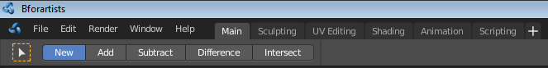

The Topbar is the area at the top that is visible in all workspaces. The topbar contains some general menus like File and Edit. It contains tabs to switch between workspaces. And it contains the tool area. This area displays options and settings for the currently active tool. In our shot the Box select tool is active. And so it shows some further settings for Box Select.
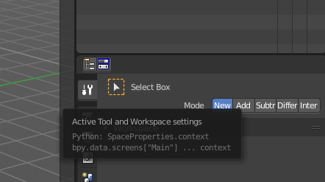
The tool area is a duplicate to the Active Tool and Workspace settings in the Properties editor, and shows the same tools. What is usually missing in the tool area is the labels.

Tool settings will be explained at a tool by tool case in the other chapters.

Header Right Click menu

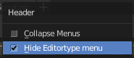
The header has, like all headers, some right click menu functionality.

Collapse Menus
Here you can make the menus in the header appear collapsed.

Hide Editortype Menu
This menu item has no purpose in the Topbar header. The Topbar header does not have a editortype menu.

File Menu
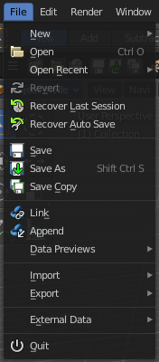
The File menu contains file related functionality.

New
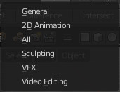
New is a sub menu. Here you can choose to create a new file with predefined Application Templates.
Application templates is a collection of workspaces for a predefined purpose.

Standard Application Templates

General
The general application template comes with the workspaces to create 3D content.

2D Animation
The 2D Animation application template comes with the workspaces to create 2D animation.

All
The All application template contains all default workspaces.

Sculpting
The Sculpting application template comes with the workspaces for sculpting needs.

VFX
The VFX application template comes with the workspaces for motion tracking.

Video Editing
The Video Editing application template comes with the workspaces for video editing.

Open
Open a blend file.

Open Recent
Open last recent blend files.

Revert
Reload the last saved file.

Recover last Session
Open the last closed blend file. (quit.blend)

Recover Autosave
Open the last autosaved blend file.

Save
Save blend file.

Save As
Save blend file as.

Save Copy
Saves a copy of the current file.

Link
Link allows you to link content from another blend file. The content remains in the other blend file. The linked blend file will be required to work with the linked content.

Append
Append allows you to append content from another blend file. The content will be copied over, and become part of the current blend file.

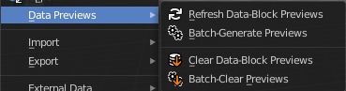
Data Previews
Data Previews is a sub menu with functionality around the Data Preview in the Bforartists file browser. The functionality in this menu creates and handles previews of the objects in a blend file.
Data Previews are displayed in the file browser when you link or append something from this file and when you use thumbnails as display method. It is meant for the case when you want to turn a blend file into a asset library. Materials, ready textured objects, etc. .
This feature is currently broken. You can't create data previews yet in Bforartists 2. Example images taken from Bforartists 1.
Workflow:
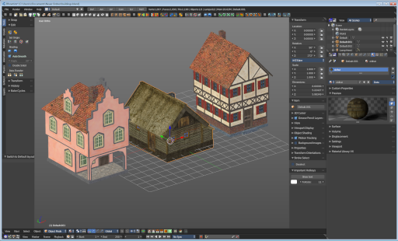
First create a scene with your assets. Make sure to remove the camera from the scene. It can work, but it can also make trouble, and prevent the batch generation to work at the blend file. And a asset library doesn't need a camera anyways. Not so important is lights, it does not make trouble like the camera. But you won't get a data preview icon for lights.
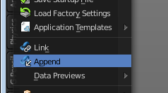
Save the scene. Restart Bforartists or create at least a new scene. We want to have a look what we currently get as preview when we want to link or append from this blend file. Make sure to turn the view in the file browser to thumbnails. It's always just the default icon for the assets. Left Materials, right the Objects.

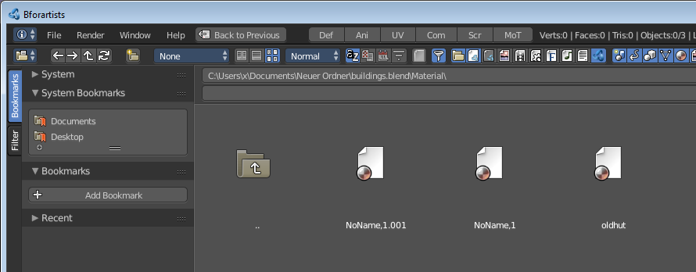
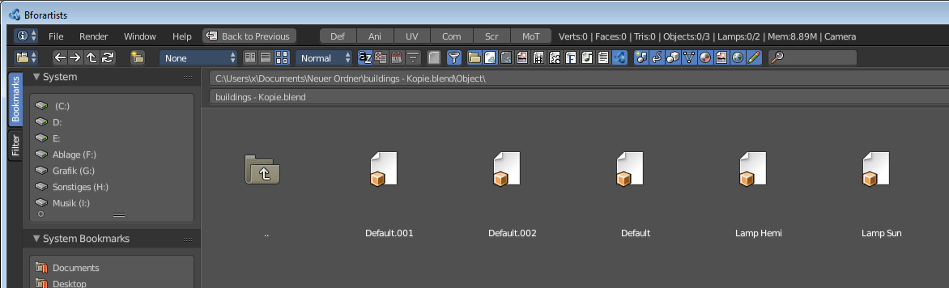

Now let's run Batch Generate Previews at this blend file.
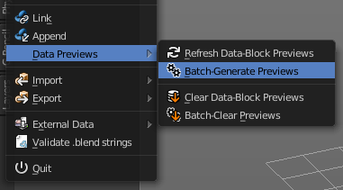
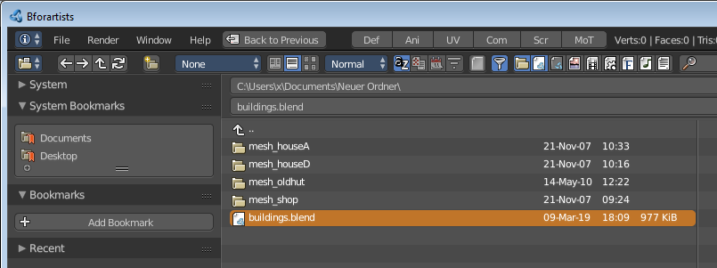

This process takes a while. Now let's try to append from the same file again. You will get proper preview thumbnails now. Left Materials, right the objects. Here you will see again that lamps have no preview icon.
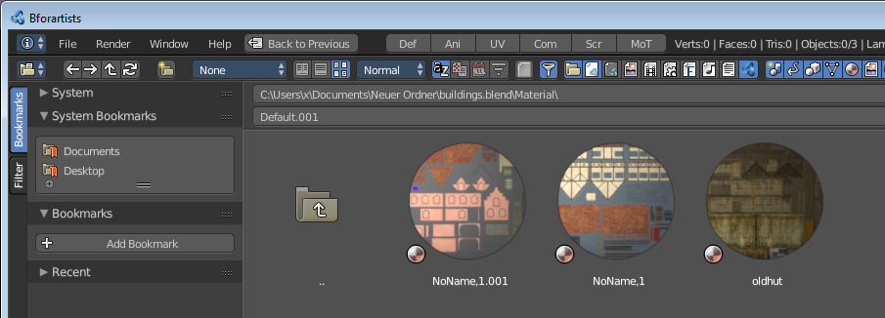
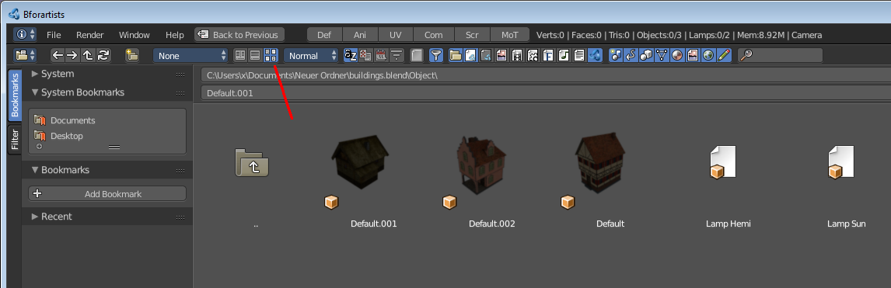

Refresh Data-Block Previews
Refreshes the existing data-block previews.

Batch Generate Previews
Generates the previews for the data objects in the selected blend file(s). The scene that you want to work at should not be loaded.

Clear Data-Block Previews
Removes existing previews for some types in the target blend file.

Batch Clear Previews
Removes all existing previews in the target blend file.

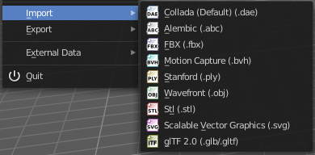
Import
Import is a sub menu with the available 3D import file formats. You will be prompted to the load dialog which provides some further import options down left in the file browser tool shelf.

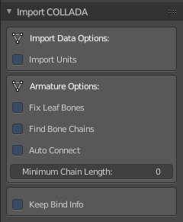
Collada
Imports a file in collada file format. Collada is a general file format that is able to store and load animation.

Import Data Options

Import Units
Imports the units that gots used to save the collada file . If unticked Blender Units will be used.

Armature Options

Fix Leaf Bones
Fix orientation of Leaf bones. Collada file formats only supports joints, not bones.

Find Bone Chains
Find best matching bone chains and ensure that the bones in the chain are connected.

Auto Connect
Auto connect parent bones that have exactly one child bone.

Minimum Chain Length
When searching bone chains disregard chains of length below this value.

Keep Bind Info
Store Bindpose Information in custom bone properties for later use in later collada export.

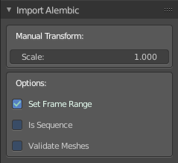
Alembic
The alembic file format is for static geometry. It does not support armatures, hair or particles.

Manual Transform

Scale
Here you can set the import scale factor.

Options

Set Frame Range
Sets the Frame range start and end point in Bforartists to match the one in the alembic file.

Is Sequence
Import sequenced files that are split in cache parts.

Validate Meshes
Check for invalid mesh data in the file. Note that this operation may take some time.

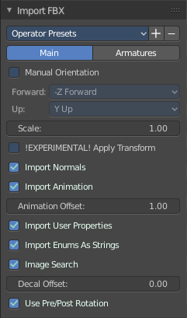
FBX
FBX is a proprietary file format from Autodesk. FBX is a general file format that is able to store and load animation.

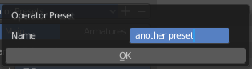
Operator Presets
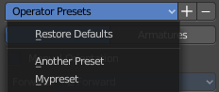
Here you can store and load presets. To add a preset, adjust the import dialog, click at the + button behind the dropdown box, add the name of the preset, and click OK. The preset will be stored automatically. To use the preset simply choose it in the dropdown box. Don't get irritated by that the dropdown box still shows "Operator Presets" when you choose your preset. The values of the chosen preset are set.
To remove a preset choose it in the dropdown box, and click at the - button behind the dropdown box. Also here, don't get irritated by that the dropdown box still shows "Operator Presets" . The chosen preset will be deleted.

Main / Armatures
The FBX import dialog has two tabs. Main and Armatures. In Main you will find the general import settings. In Armatures you will find armature related settings.

Main

Manual Orientation
Here you can choose to adjust a custom orientation to import your data. You can adjust the Forward and Up values to your needs.

Scale
Here you can adjust the scale factor at import.

!Experimental! Apply Transform
Bake space transform into object data. This avoids unwanted rotations when the target space is not aligned with the Bforartists space. Warning! This feature is experimental. Use at own risk.

Import Normals
Import Normals of the mesh.

Import Animation
Import animation.

Animation Offset
Here you can adjust a offset in frames for the imported animation.

Import User Properties
Import User properties as custom properties.

Import Enums as Strings
Stores enumeration values as strings.

Image Search
Search sub directions for associated images.

Decal Offset
Displace geometry of alpha meshes.

Use Pre/ Post Rotation
Use Pre or Post Rotation from FBX transform. This feature may not work in all cases.

Armatures

Ignore Leaf Bones
Ignore the last bone at the end of the chain.

Force Connect Children
Force connection of the children bones to their parent.

Automatic Bone Orientation
Try to align the mayor bone axis with the bone children.

Primary and secondary Bone Axis
Here you can manually adjust the bone orientation per axis. Note that this features are greyed out when Automatic Bone Orientation is ticked.

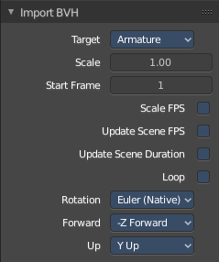
Motion Capture (BVH)
The Biovision Hierarchy (BVH) character animation file format is a file format to carry motion capture data.

Target
You can either target a armature or a object.

Scale
The import scale.

Start Frame
The start frame for the animation.

Scale FPS
Scale the framerate of the BVH file to the current scenes. With off every frame of the BVH is one frame in Bforartists.

Update Scene FPS
Sets the scene frame rate to that of the BVH file. Note that this nullifies the Scale FPS feature since the scale will be 1:1.

Update Scene Duration
Extend the scene duration to be the one of the BVH file duration.

Loop
Loop the animation playback.

Rotation
The rotation type.

Forward
The forward orientation.

Up
The Up orientation.

Stanford (PLY)
The Stanford Triangle Format was designed to store three-dimensional data from 3D scanners. It is a static file format for mesh data, and cannot carry animation data.
Stanford PLY has no import options.

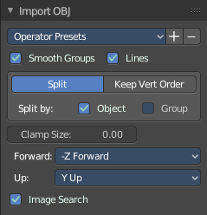
Wavefront(OBJ)
Wavefront Obj is a file format for static geometry. And while you can still create a sequence of meshes for animation with it (some software stores shapekeys that way for example), you cannot store animation in the file. It is also unique since it is usually made of two files. A OBJ part that contains the mesh data. And a MTL part that contains the material including the connected textures.

Operator Presets
Here you can store and load presets. To add a preset, adjust the import dialog, click at the + button behind the dropdown box, add the name of the preset, and click OK. The preset will be stored automatically. To use the preset simply choose it in the dropdown box. Don't get irritated by that the dropdown box still shows "Operator Presets" when you choose your preset. The values of the chosen preset are set.
To remove a preset choose it in the dropdown box, and click at the - button behind the dropdown box. Also here, don't get irritated by that the dropdown box still shows "Operator Presets" . The chosen preset will be deleted.

Smooth Groups
Surround smooth groups by sharp edges.

Lines
Import Lines and Faces with 2 verts as edge.

Split / Keep Vert Order
Split splits the mesh up. Keep Vertex Order imports everything as one mesh. Both methods have some further options.

Split by Object
Import loose meshparts as single objects.

Split by Group
Import Obj Groups as meshes.

Keep Vert Order Poly Groups
Import Obj groups as vertex groups.

Clamp Size
Clamp bounds under this value. A value of zero disables this feature.

Forward
The Forward orientation at import.

Up
The Up orientation at import.

Image Search
Search sub directions for associated images.

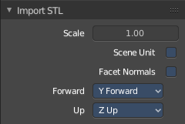
STL
STL (Standard Triangulation/Tesselation Language ) is a standard format for many cad software. It is a format for static geometry, it cannot handle animation. The format is popular for 3d printing purposes.

Scale
The import scale.

Scene Unit
Apply the scene unit at the geometry at import.

Facet Normals
Import the geometry with faceted faces.

Forward
The Forward orientation at import.

Up
The Up orientation at import.

Scalable Vector Graphics (SVG)
Scalable Vector Graphics is usually a 2D file format to describe vector graphics. But Vector graphics are also curves. Which can be used in a 3 dimensional space.
SVG has no import properties.

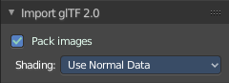
glTF 2.0 (glb, gltf )
The GL Transmission Format fron the Khronos Group is a file format for 3D scenes and models, and is based at the JSON standard.

Pack Images
Pack all images into the Blend file at loading the glTF file.

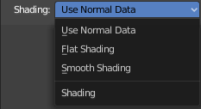
Shading
Here you can define the shading of the imported geometry.
Use Normal Data uses the existing normals.
Flat shading shades the whole mesh flat and facetted.
Smooth shading shades the whole mesh smooth.

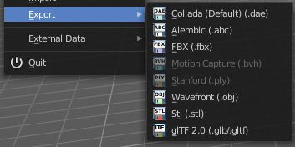
Export
Export is a sub menu with the available export formats.

Collada
Exports a file in collada file format. Collada is a general file format that is able to store and load animation.

Operator Presets
Here you can store and load presets. To add a preset, adjust the import dialog, click at the + button behind the dropdown box, add the name of the preset, and click OK. The preset will be stored automatically. To use the preset simply choose it in the dropdown box. Don't get irritated by that the dropdown box still shows "Operator Presets" when you choose your preset. The values of the chosen preset are set.
To remove a preset choose it in the dropdown box, and click at the - button behind the dropdown box. Also here, don't get irritated by that the dropdown box still shows "Operator Presets" . The chosen preset will be deleted.

The Collada exporter is divided into several subtabs since it would be too much to display all settings at once.

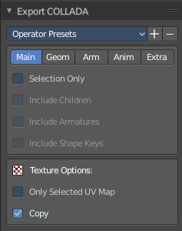
Main

Selection Only
Only export selected elements, not the whole scene.

Include Children
Export all children of selected objects, even if not selected.

Include Armatures
Export related armatures, even if not selected.

Include Shape Keys
Export all shape keys from Mesh Objects

Texture Options

Only Selected UV Map
Export only the selected UV map

Copy
Copy the textures to the same folder where the .dae file is exported.

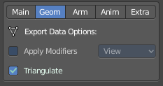
Geom
The geometry export section.

Export Data Options

Apply Modifiers
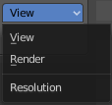
Applies the modifiers for export. The resolution can be adjusted in the dropdown box behind the Apply Modifiers checkbox. You can choose between View and Render.

Triangulate
Triangulates the mesh at export.

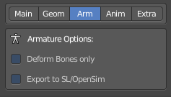
Arm
The armature export section.

Armature Options

Deform Bones only
Only export deforming bones with armatures.

Export to SL/OpenSim
Compatibility mode for SL, OpenSim and other compatible online worlds.

Anim
The Animation export section.

Include Animations
Export Animation if available.

Samples/Curves
Export samle keys or curves keys.

Transformation Type
The transformation type for translation, scale and rotation. Matrix or TransRotLoc.

Keep Smooth Curve
Just available with TransRotLoc transformation type. Export also the curve handles if available.

Sampling Rate
The distance between two keyframes.

Keep Keyframes
Use existing keyframes as sample points.

All Keyed Curves
Export also curves that has just one key or are completely flat.

Include all Actions
Export also unassigned actions.

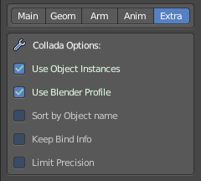
Extra
Some extra export settings.

Collada Options

Use Object Instances
Instantiate multiple objects from same data.

Use Blender Profile
Export Blender specific settings for shader, bones, materials, etc.

Sort by Object Name
Sort exported data by name.

Keep Bind Info
Store Bind Pose Information in custom bone properties for later use during Collada export.

Limit Precision
Reduce the precision of the exported data to 6 digits.

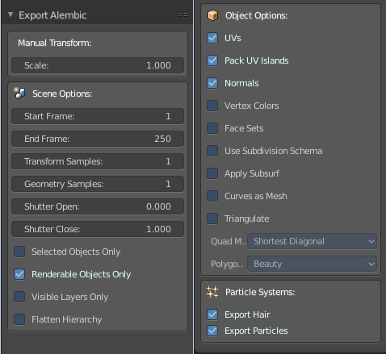
Alembic
The alembic file format is for static geometry. It does not support armatures, hair or particles. However, there are some options to export at least some data of it.
The alembic export options are divided into four sections.

Manual Transform

Scale
The export scale factor.

Scene Options

Start Frame
The start frame of the export.

End Frame
The end frame of the export.

Transform Samples
Number of times per frame at which animated transformations are sampled.

Geometry Samples
Number of times per frame at which geometry transformations are sampled.

Shutter Open
The start frame to sample transform and geometry samples. Valid range is -1 to 1. -1 indicates the previous frame, 0 indicates the current frame, and 1 indicates the next frame.

Shutter Closed
The end frame to sample transform and geometry samples. Valid range is -1 to 1. -1 indicates the previous frame, 0 indicates the current frame, and 1 indicates the next frame.

Selected Objects only
Export just selected objects.

Renderable Objects only
Export just renderable objects.

Visible Layers only
Export just objects in visible layers.

Flatten Hierarchy
Remove parent / children relationship.

Object Options

UV's
Export UV's. Note that Alembic just supports a single UV map.

Pack UV Islands
Export UV's with packed islands.

Normals
Export Normals.

Vertex Colors
Export Vertex Colors.

Face Sets
Export per Face shading group assignments.

Use Subdivision Schema
Export meshes using Alembic's subdivision schema.

Apply Subsurf
Export subdivision surfaces as meshes. Means apply subdivision modifier before export.

Curves as Mesh
Export Curces and Nurbs surfaces as meshes.

Triangulate
Triangulate meshes before export.

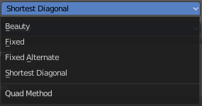
Quad Method
The quad method that gets used to triangulate the meshes.
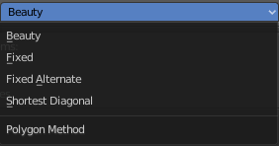

Polygon Method
The polygon method that gets used to triangulate the meshes.

Particle Systems
Alembic does not support hair or particles. However, here you can find some options to export at least some data of it.

Export Hair
Export hair particle systems as animated curves.

Export Particles
Export non-hair particles.

FBX
FBX is a proprietary file format from Autodesk. FBX is a general file format that is able to store and load animation.

Operator Presets
Here you can store and load presets. To add a preset, adjust the import dialog, click at the + button behind the dropdown box, add the name of the preset, and click OK. The preset will be stored automatically. To use the preset simply choose it in the dropdown box. Don't get irritated by that the dropdown box still shows "Operator Presets" when you choose your preset. The values of the chosen preset are set.
To remove a preset choose it in the dropdown box, and click at the - button behind the dropdown box. Also here, don't get irritated by that the dropdown box still shows "Operator Presets" . The chosen preset will be deleted.

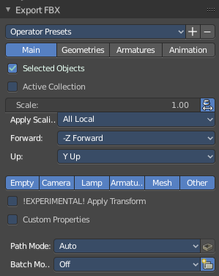
The FBX exporter is divided into several tabs since it would be too much to display all settings at once.

Main

Selected Objects
Export just selected objects.

Active Collection
Export just the active collection.

Scale
The scale factor for export.

Apply Unit Scale
Take the current Blender Units into account.

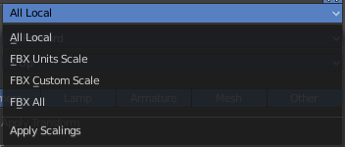
Apply Scalings
How to apply custom and unit scaling in the generated FBX file.

Forward
The forward orientation.

Up
The up orientation.

Empty / Camera / Lamp / Armature / Mesh / Other
What kind of object you want to export. Holding shift key adds to the current selection.

!Experimental! Apply Transform
Bake space transform into object data.

Custom Properties
Export custom properties if available.

Path Mode
Method used to reference paths.

Embed Textures
Just valid for method Copy. Embeds the textures into the FBX Binary.

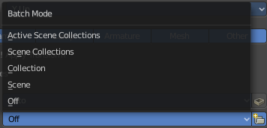
Batch Mode
Here you can adjust some further export methods. You can for example export every collection into a own FBX file.

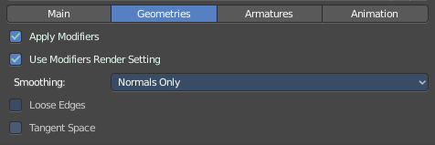
Geometries

Apply Modifiers
Apply existing modifiers before exporting.

Use Modifieres Render Settings
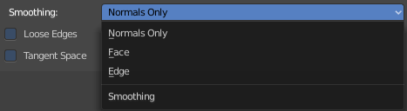
Use Render settings when applying modifiers. For example, the Subdivision Surface modifier has two independant setttings for the workspace and the rendering.

Smoothing
Define what smoothing information gets exported.

Loose Edges
Export loose edges. Loose edges are polygons with just two vertices.

Tangent Space
Add binormal and tangent vectors together with the tangent space information. This feature just works with tris or quads.

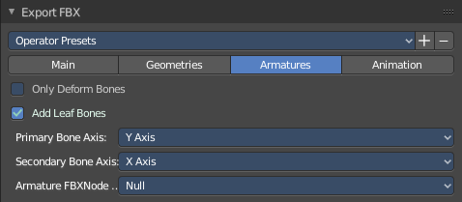
Armatures

Only Deform Bones
Only export deforming bones, and none deforming ones when they have children.

Add Leaf Bones
Add a final bone at the end of every bone chain.

Primary Bone Axis
The primary bone axis orientation.

Secondary Bone Axis
The secondary bone axis orientation.

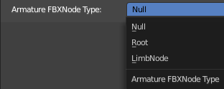
Armature FBX Node Type
FBX type of node used to represent a Blender Bone.

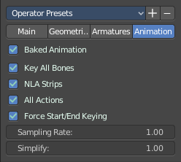
Animation

Baked Animation
Export baked keyframe animation.

Key all Bones
Force export at least one key of animation for all bones.

NLA Strips
Export each non muted NLA strip.

All Actions
Export each action as a separated FBX anim stack.

Force Start/ End Keying
Always add a keyframe at start and end of actions for animation channels.

Sampling Rate
How often to evaluate animated values, in frames.

Simplify
Here you can simplify the animation. 0.0 to disable. 1.0 does not simplify at all. Higher values simplifies the animation then.

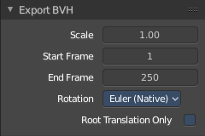
BVH
The Biovision Hierarchy (BVH) character animation file format is a file format to carry motion capture data.
To export BVH you need to have a armature with animation selected.

Scale
The scale factor for the export.

Start Frame
The start frame of the animation

End Frame
The end frame of the animation

Rotation
The rotation order that is defined in the BVH file.

Root Translation Only
Only write out translation values for the root bone.

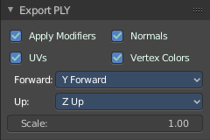
Stanford (PLY)
The Stanford Triangle Format was designed to store three-dimensional data from 3D scanners. It is a static file format for mesh data, and cannot carry animation data.

Apply Modifiers
Apply all modifiers before export.

Normals
Export normals.

UV's
Export UV's

Vertex Colors
Export Vertex Colors.

Forward
The forward orientation.

Up
The up orientation.

Scale
The scale factor for the export.

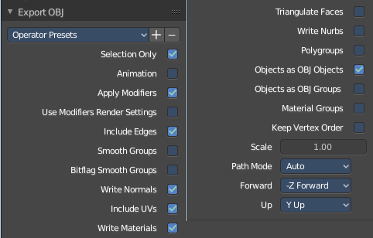
Wavefront(OBJ)
Wavefront Obj is a file format for static geometry. And while you can still create a sequence of meshes for animation with it (some software stores shapekeys that way for example), you cannot store animation in the file. It is also unique since it is usually made of two files. A OBJ part that contains the mesh data. And a MTL part that contains the material including the connected textures.

Operator Presets
Here you can store and load presets. To add a preset, adjust the import dialog, click at the + button behind the dropdown box, add the name of the preset, and click OK. The preset will be stored automatically. To use the preset simply choose it in the dropdown box. Don't get irritated by that the dropdown box still shows "Operator Presets" when you choose your preset. The values of the chosen preset are set.
To remove a preset choose it in the dropdown box, and click at the - button behind the dropdown box. Also here, don't get irritated by that the dropdown box still shows "Operator Presets" . The chosen preset will be deleted.

Selection Only
Export only the selected object(s).

Animation
Write out a Obj mesh for each frame.

Apply Modifiers
Apply Modifiers before export.

Use Modifier Render Settings
SDS modifier has a viewport and a render resolution. When ticked the render resolution gets chosen.

Inlcude Edges
Include loose edges at export. Loose edges are defined by two vertices only.

Smooth Groups
Write sharp edges as smooth groups.

Bitflag Smooth Groups
Write sharp edges as smooth groups, but generate smooth groups id's as bitflags.

Write Normals
Export Normals

Include UV's
Export UV's

Write Materials
Export materials. Note that the OBJ file format cannot carry the Blender material settings. The Obj file format uses a primitive Phong shader.

Triangulate Faces
Triangulate Faces at export.

Write Nurbs
Export Nurbs curves

Polygroups
Export Polygroups

Objects as OBJ Objects
Export objects as OBJ Objects.

Objects as OBJ Groups
Export objects as OBJ groups.

Material Groups
Export material groups.

Keep Vertex Order
Keep the vertex order at export.

Scale
The scale factor for the export.

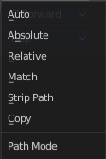
Path Mode
How the paths like texture paths gets handled at export.

Forward
The forward orientation.

Up
The up Orientation.

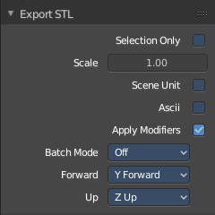
STL
STL (Standard Triangulation/Tesselation Language ) is a standard format for many cad software. It is a format for static geometry, it cannot handle animation. The format is popular for 3d printing purposes.

Selected Only
Export only the selected object(s).

Scale
The import scale.

Scene Unit
Apply the scene unit at the geometry at export.

Ascii
You can either export the file as binary format or as ascii format.

Apply Modifiers
Apply all modifiers before export.

Batch Mode
Export all geometry to one file or create a file for every object.

Forward
The Forward orientation at export.

Up
The Up orientation at export.

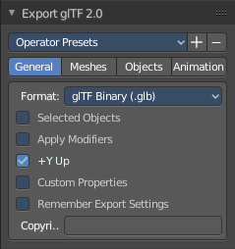
glTF 2.0 (glb, gltf )
The GL Transmission Format fron the Khronos Group is a file format for 3D scenes and models, and is based at the JSON standard.

Operator Presets
Here you can store and load presets. To add a preset, adjust the import dialog, click at the + button behind the dropdown box, add the name of the preset, and click OK. The preset will be stored automatically. To use the preset simply choose it in the dropdown box. Don't get irritated by that the dropdown box still shows "Operator Presets" when you choose your preset. The values of the chosen preset are set.
To remove a preset choose it in the dropdown box, and click at the - button behind the dropdown box. Also here, don't get irritated by that the dropdown box still shows "Operator Presets" . The chosen preset will be deleted.
glTF 2.0 exporter is divided into several tabs since it would be too much to display all settings at once.

General

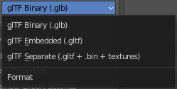
Format
Here you can choose between three export formats. Binary, Embedded and Separate.

Selected Only
Export only the selected object(s).

Apply Modifiers
Apply all modifiers before export.

Y up
Export with Y Up orientation.

Custom Properties
Export custom properties as glTF extras.

Remember Export Settings
Store glTF settings in the blender project. You need to save the project then.

Copyright
Here you can enter a custom copyright string.

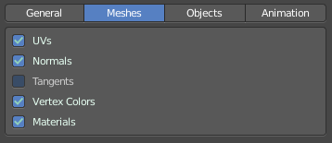
Meshes

UV's
Export UV's

Normals
Export Normals.

Tangents
Export Tangents.

Vertex Colors
Export Vertex Colors.

Materials
Export Materials.
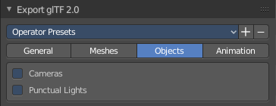

Objects

Cameras
Export Cameras.

Punctual Lights
Export Punctual Lights.

Animation

Use Current Frame
Export the scene in current animation frame.

Animations
Export active actions and NLA tracks.

Limit to Playback Range
Clips animations to selected playback range.

Sampling Rate
How often to evaluate animated values in frames

Always Sample Animations
Apply sampling to all animations.

Skinning
Export Skinning data.

Bake Skinning Constraints
Apply skinning constraints to armatures.

Include all Bone Influences
Allow vertex influences greater 4.

Shape Keys
Export Shape Keys. Also called Morph Targets.

Shape Key Normals
Export vertex normals with shape keys.

Shape Key Tangents
Export vertex tangents with shape keys.

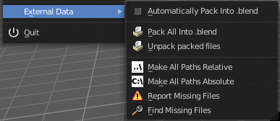
External Data
A Blend file may work with external data. Textures for example. Or text files. Or other Blend files, used as libraries.
In this menu you can adjust some settings for external data.
External data like textures or text files can also be packed directly into the blend file. This has some advantages, like that now all data is in one file. But also some drawbacks. Texture editing is for example not longer possible. You would have to export the texture first to be able to save the modifications.
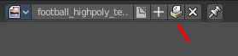
Packed data displays a packed icon in the dropdown box. This example is from the header of the UV editor. But you can see this icon also in the material editor at the texture node then.
Library Blend files cannot be packed. Use append instead of link to have the data of another blend file in the blend file.

Automatically Pack into .blend
Automatically pack all files into the blend file. Don't forget to save the blend file. Note that this greys out the two menu items Pack all into Blend and Unpack packed Files.

Pack All into .blend
Packs all external data into the blend file. Note that the paths must fit, and the external data must be available. A common pitfall here is that the textures uses absolute paths, and are moved to another location meanwhile. See Make all Paths Relative or Find missing Files. Or that you have a not longer existing file linked that shouldn't be in the blend file at all. See Outliner, Orphan Data.
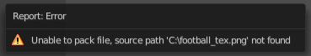
You will get a warning when something is missing.

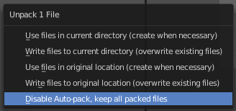
Unpack packed files
Unpack packed files exports all packed data. You will get an options menu where you can choose between several different unpack methods.

Use Files in current Directory (create when necessary)
Extracts all files to the current directory of the blend file. If the files in the current directory exists, reuse it. Else extract the ones from the blend file.
NOTE! The title is misleading, it does NOT write the files to the current directory. But into a subfolder, textures for example, in the current directory. Which gets created if necessary. And this option is not to change.

Write files to current directory (overwrite existing files)
Extracts all files to the current directory of the blend file, and writes it to the current directory. Existing content will be overwritten.
NOTE! The title is misleading, it does NOT write the files to the current directory. But into a subfolder, textures for example, in the current directory. Which gets created if necessary. And this option is not to change.

Use files in original location (create when necessary)
Extracts all files into their original directories where they were before packing them into the blend file. If the files in the original directory exists, reuse it. Else extract the ones from the blend file. This feature uses absolute paths.

Write files to original location(overwrite existing files)
Extracts all files into their original directories where they were before packing them into the blend file. If the files in the original directory exists, reuse it. Else extract the ones from the blend file. This feature uses absolute paths.

Make All Paths Relative
Make all paths relative means the path will be shortened to just the file name. For example, C:\myfolder\mysubfolder\mytexture.jpg turns into texture.jpg . Relative paths allows you to move the whole project folder to another location. The file paths will still be valid.

Make all Paths Absolute
Make all paths relative means the path will be shortened to just the file name. For example, turns into texture.jpg C:\myfolder\mysubfolder\mytexture.jpg. Absolute paths requires the full valid path for all files.

Report Missing Files
Scans through the blend file and tries to find missing files. You will get a warning when a missing file is found.

Find Missing Files
Browse for the new location of moved files.

Quit
Quit Bforartists.

Edit Menu
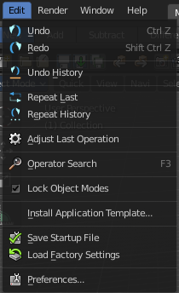

Undo
Reverts the last step.
Note. Bforartists uses two separated histories for the Object Mode and the Edit Mode. Means when you leave the Edit mode then you will loose the undo steps in the edit mode.

Redo
Rolls back your last Undo action.

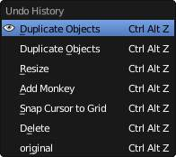
Undo History
The Undo History is a list of the last operations. Her you can roll back to a specific step.
Note that this Undo History is a session history, and does not save to the Blend file.

Repeat Last
Repeat last repeats the last operation. For example, when you have moved a object by 5 in X, then it moves the object by 5 in X with every repeat last step.

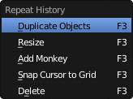
Repeat History
Repeat History calls a menu with the last actions where yon can choose an action to be repeated.

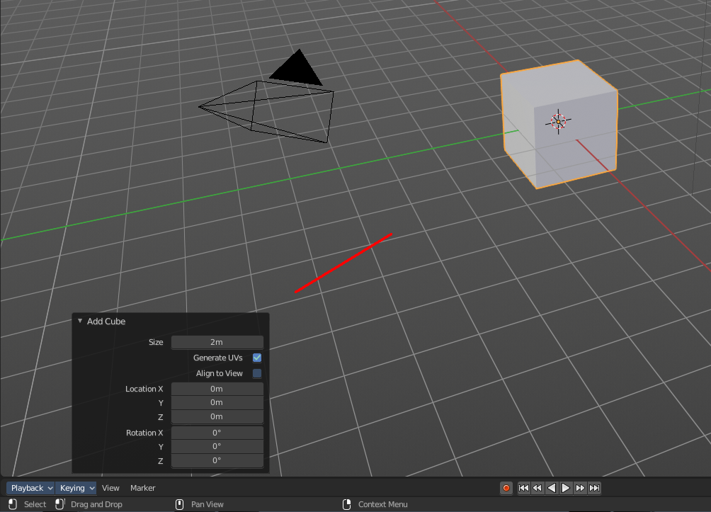
Adjust Last Operation
Some operations have settings, and can be further tweaked. It's the Blender ass forward concept for setting up a operation. In other software you set up an operation and perform it then with this settings. In Blender you first perform the operation, and tweak its settings afterwards. At least sometimes, this concept is not consistent. Bforartists is a fork of Blender. And so we have to live with this concept too.
For example, when you create a primitive, then you may want to adjust the size, or tick options like generate UV's at creation. This is done in the Last Operator panel. This Last Operator Panel is usually down left in the view.
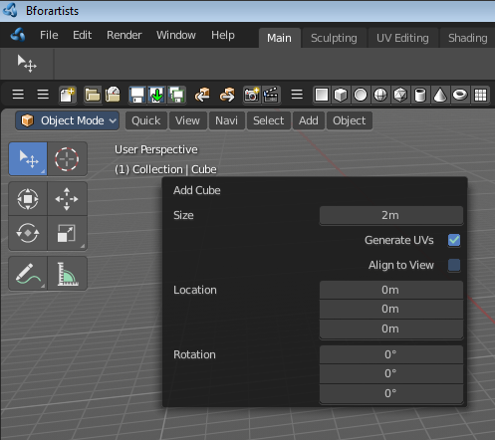
The Adjust Last Operation calls exactly this content as a menu popup.
Note that when you perform another operation, like moving the cube after creation, then the last operation content for creation is gone. It will now display the last operation content for the transform operation.

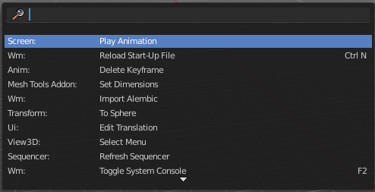
Operator Search
This menu item calls a search menu where you can search through all available operators, and perform them if needed. Think of it as one gigantic searchable dropdown menu that contains everything available.

Even operators that have no menu entries are listed. Which is useful for scripting purposes, when you want to perform a script operation, but don't have a menu button (yet).

You can navigate with the mouse or with arrow up and down buttons. Performing an operator can be done by clicking at it or by hitting enter.

Note that this search just lists the old traditional operators from before Blender 2.80. Not the ones in the Tool Shelf, which is a completely independant tool system.

Lock Object Modes
Restrict select to the current mode. For example, with this option off you may still accidentally select another object when you are in Edit mode.

Application Templates
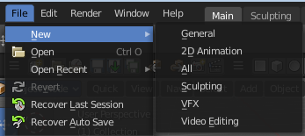
Here you can load a new application template.
Application templates is a predefined set of workspaces with its own setup. It can contain its own layout, theming, its own startup file, its own addon set and scripts, a own keymap and own lighting, and its own User Preferences.
Bforartists comes with six internal application templates already. Have a look at the "new" menu item in the file menu. Clicking at one of the menu items creates in fact a new scene by using one of the existing application templates.
Note that the whole application template system is buggy. And may not work!

How to create a application template
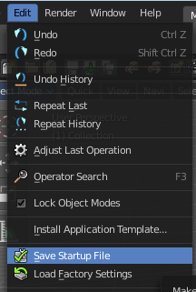
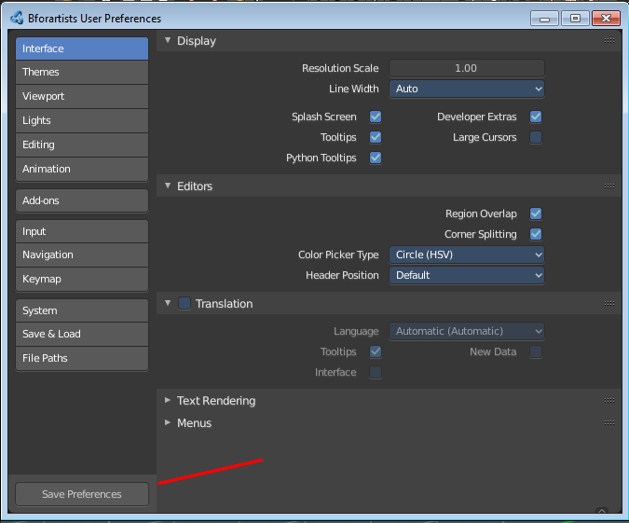
A application template is basically a zip file that contains a startup.blend, a userpref.blend, a splash.png and a __init__.py file that defines this all as a application template.
startup.blend and userpref.blend can be created in the Edit menu. Save startup file and User Preferences. So tweak everything to your needs, and save those two things.

At Windows you will find them in the appdata directory in the Bforartists folder.
At Linux it's in /home/yourusername/.config/bforartists/2.80/config/
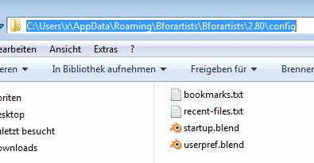
Copy those two files, startup.blend and userpref.blend, and throw them into a folder where you want to build the application template in. Rename this folder to AT_01, or to whatever name you want it to use.
Next create a png image as a splash screen for your template, and save it as splash.png into the AT_01 folder. The required size is 501x250. Everything else will throw an error, and you won't be able to see the new splash. You can alternatively also create a splashx2.png file in double size. This is for hidpi monitors.
The required __init__.py file is a python file with a def register and a def unregister.

def register():
print(Registering application template : {0}.format(__name__)
def unregister():
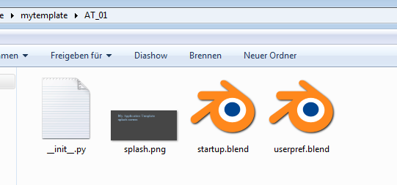
print(Unregistering application template : {0}.format(__name__)

So copy over this text, and save this file as __init__.py in the AT_01 folder
We should now have four files in the AT_01 folder. Zip the AT_01 folder. The template is finished for installing.
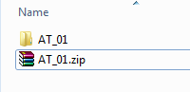
But as a last step, and before you install the template, remove the startup.blend and userpref.blend that we have created to build the application template from the config directory, to have a clean environment.
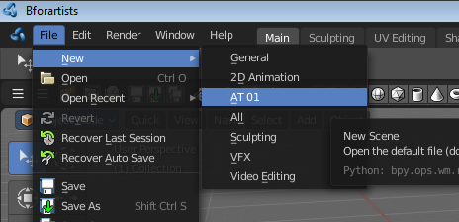
Once installed you will find the new application template in the New menu.
To remove an application template you need to remove its data in the config folder. There is no functionality to uninstall it.

Save Startup File
Saves a startup.blend with the current configuration.
A startup.blend stores layout informations. Editor layouts, default values, if a panel is open or closed, etc. .

Load Factory Settings
Resets Bforartists into a fresh installed state. All customer modifications, like activated addons, changes at the layout, etc. will be ignored.

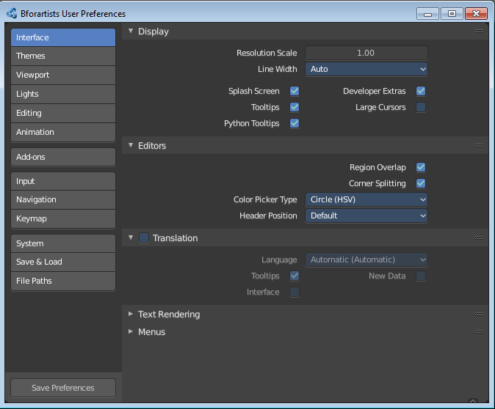
Preferences
Opens the Preferences window. Here you can adjust various settings.

Render Menu
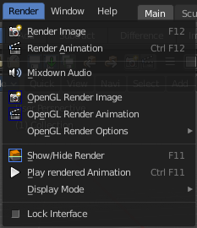
This menu contains functionality around rendering.

Most of the render settings can be found in the Properties editor in the Render tab. And here you can also choose the render engine.

Render Image
Renders the current scene as an image by using the current chosen renderer.

Render Animation
Renders the current scene as an animation by using the current chosen renderer.

Mixdown Audio
Mixdown and export the scene's audio to an audio file. You will open an export dialog when you click at Mixdown Audio. Further Audio settings can be found in the Properties editor.

Options
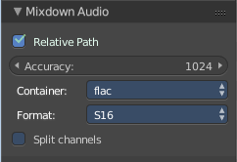
The options can be found downleft in the Save dialog.

Relative Path
Select the file relative to the blend-file.

Accuracy
Sample accuracy, important for animation data (the lower the value, the more accurate).

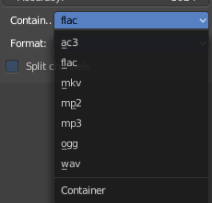
Containers
Here you can choose between different audio export formats.

Format
Some Audio Containers also have option to choose a codec. For more information see here.

Split Channels
Each audio channel will be rendered into a separate file.

OpenGL Render Image
Renders an Image, using the Viewport OpenGL renderer.

OpenGL Render Animation
Renders an animation, using the Viewport OpenGL renderer.
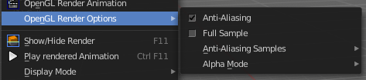

Open GL Render Options
Here you can adjust the look of the Open GL rendering.

Show / Hide Render
Toggles the display of the render view.

Play rendered Animation
Plays back the rendered animation sequence.

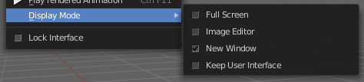
Display Mode
Here you can define how the render view gets displayed.

Lock Interface
Lock the interface during rendering in favour to give more memory to the rendering.

Window Menu
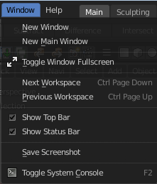
Window related functionality.

New Window
Creates a new instance of Bforartists. But without Top Bar.

New Main Window
Creates a new instance of Bforartists with its own workspace and scene settings and with the Top Bar.

Toggle Window Fullscreen
Makes Bforartists fullscreen.

Next Workspace
Cycle to next workspace.

Previous Workspace
Cycle to previous workspace.

Show Top Bar
Display the top bar.

Show Status Bar
Display the footer.

Save Screenshot
Saves a screenshot.

Toggle System Console
Toggles the System console. This is a Windows feature. Under Linux and Mac you can use the bash.

Help Menu

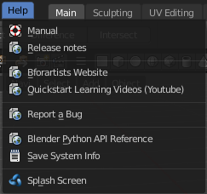
The Help menu contains some external links to useful resources. Here you can also find a utility to save the system information and to show the splash screen.

Manual
Opens the Bforartists Manual page in a web browser.

Release Note
Opens the Bforartists Release note page in a web browser.

Bforartists Website
Opens the Bforartists page in a web browser.

Quickstart Learning Videos
Opens the Bforartists Quickstart Youtube channel. Here you can find some learning videos.

Report a Bug
Here you can report a bug. The link leads you to Github. You need to create a Github account to be able to report a bug.

Blender Python API reference
Opens the Blender Python API reference page in a web browser.

Save System Info
Here you can save your system informations to a text file.

Splash Screen
Reveals the Splash Screen.

Navigation Tabs
With the tabs you can switch between different workspaces of a application template.
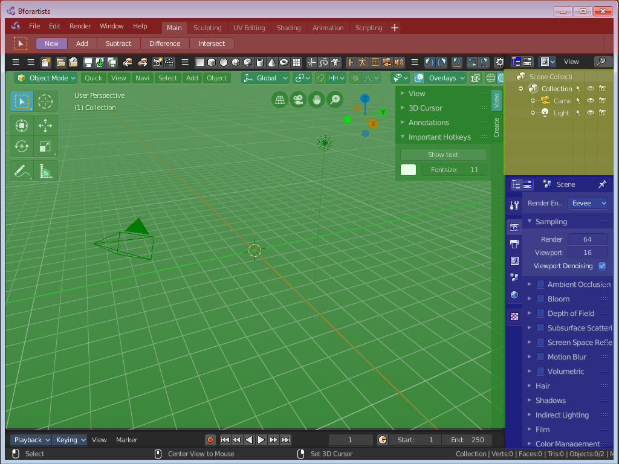
Application templates are a collection of Workspaces. A Workspace is a layout of screens and special setups. Like in what mode the workspace starts, how the windows are arranged and so on.

Every layout is made of several editors. The 3D View, a Properties Editor, the header and footer, the Toolbar at the top, and so on.

Adding a new tab
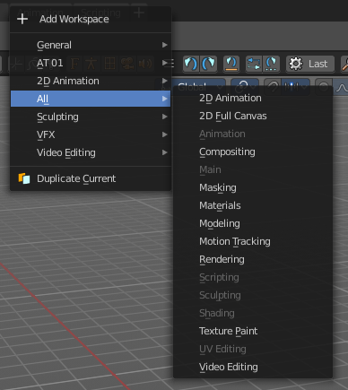
You can also add a new workspace to the existing ones. For this you can either add one of the existing workspaces from the Add Workspace menu that hides under the + button at the right. The greyed out menu items are already added to the Tabs.

The other way is by duplicating the current workspace, tweak it to your needs, and rename it then. This can also be done in the Add Workspace menu. Duplicate Current.

When done, save the startup file to make the change permanent. Be careful here, this overwrites the current startup.blend file with all its settings.

Rename a tab
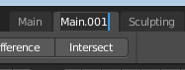
To rename a tab double click at it. The name turns into a edit box. And you can edit the name of the tab.

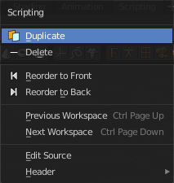
Tab Right Click Menu
When you right click at a tab then you will reveal a menu with further functionality.

Duplicate
Duplicates the workspace with all its settings.

Delete
Deletes the workspace with all its settings.

Reorder to Front
Orders the tab to be the first in the list.

Reorder to Back
Orders the tab to be the last in the list.

Previous Workspace
Cycle to the previous workspace.

Next Workspace
Cycle to the next workspace.

Edit Source
Open the Python script that contains this button in the text editor. Note that you need to have a text editor open.

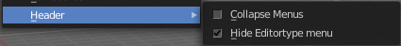
Header
Same menu than the right click menu in the header area.

Collapse Menus
Here you can make the menus in the header appear collapsed.

Hide Editortype Menu
This menu item has no purpose in the Topbar header. The Topbar header does not have a editortype menu.

Standard Workspaces

Default  This layout is for general 3D work. Here you work at your 3D scene. Here happens modeling, texturing, etc. . It is also the workspace with which Bforartists opens up. It contains a 3D View editor, a Info editor, a Timeline editor, a Outliner editor and a Properties editor.  It starts in Object Mode. | 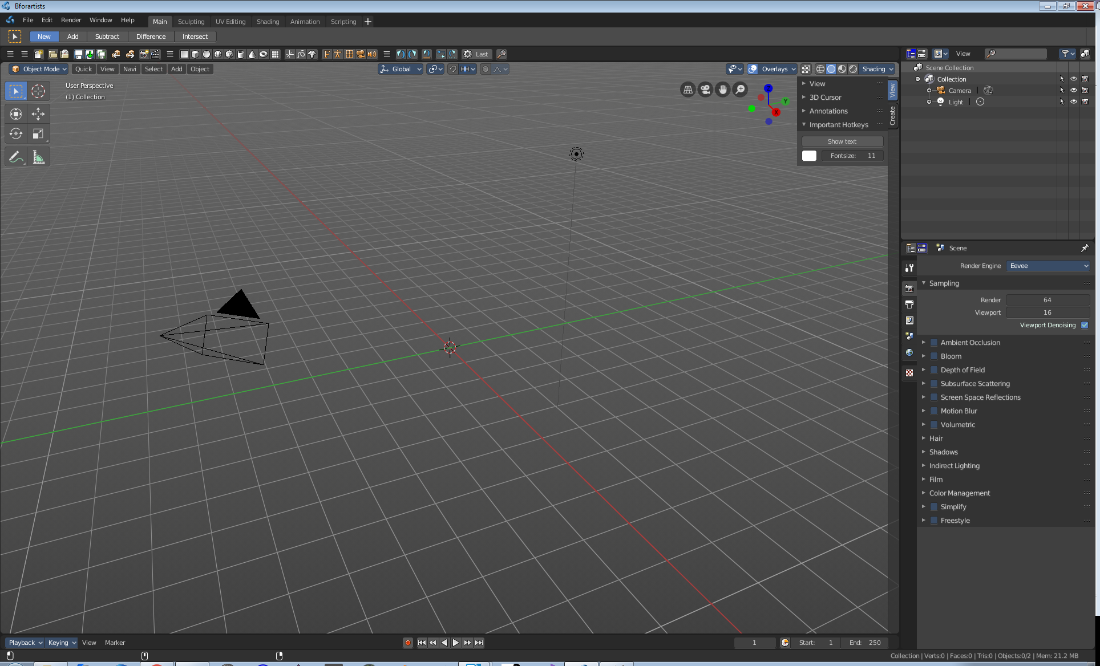

Modeling
Same as the Default workspace.

It starts in Object Mode.

Sculpting  This workspace is dedicated to sculpting.  It starts in Sculpt Mode in case you have a object in the scene. | 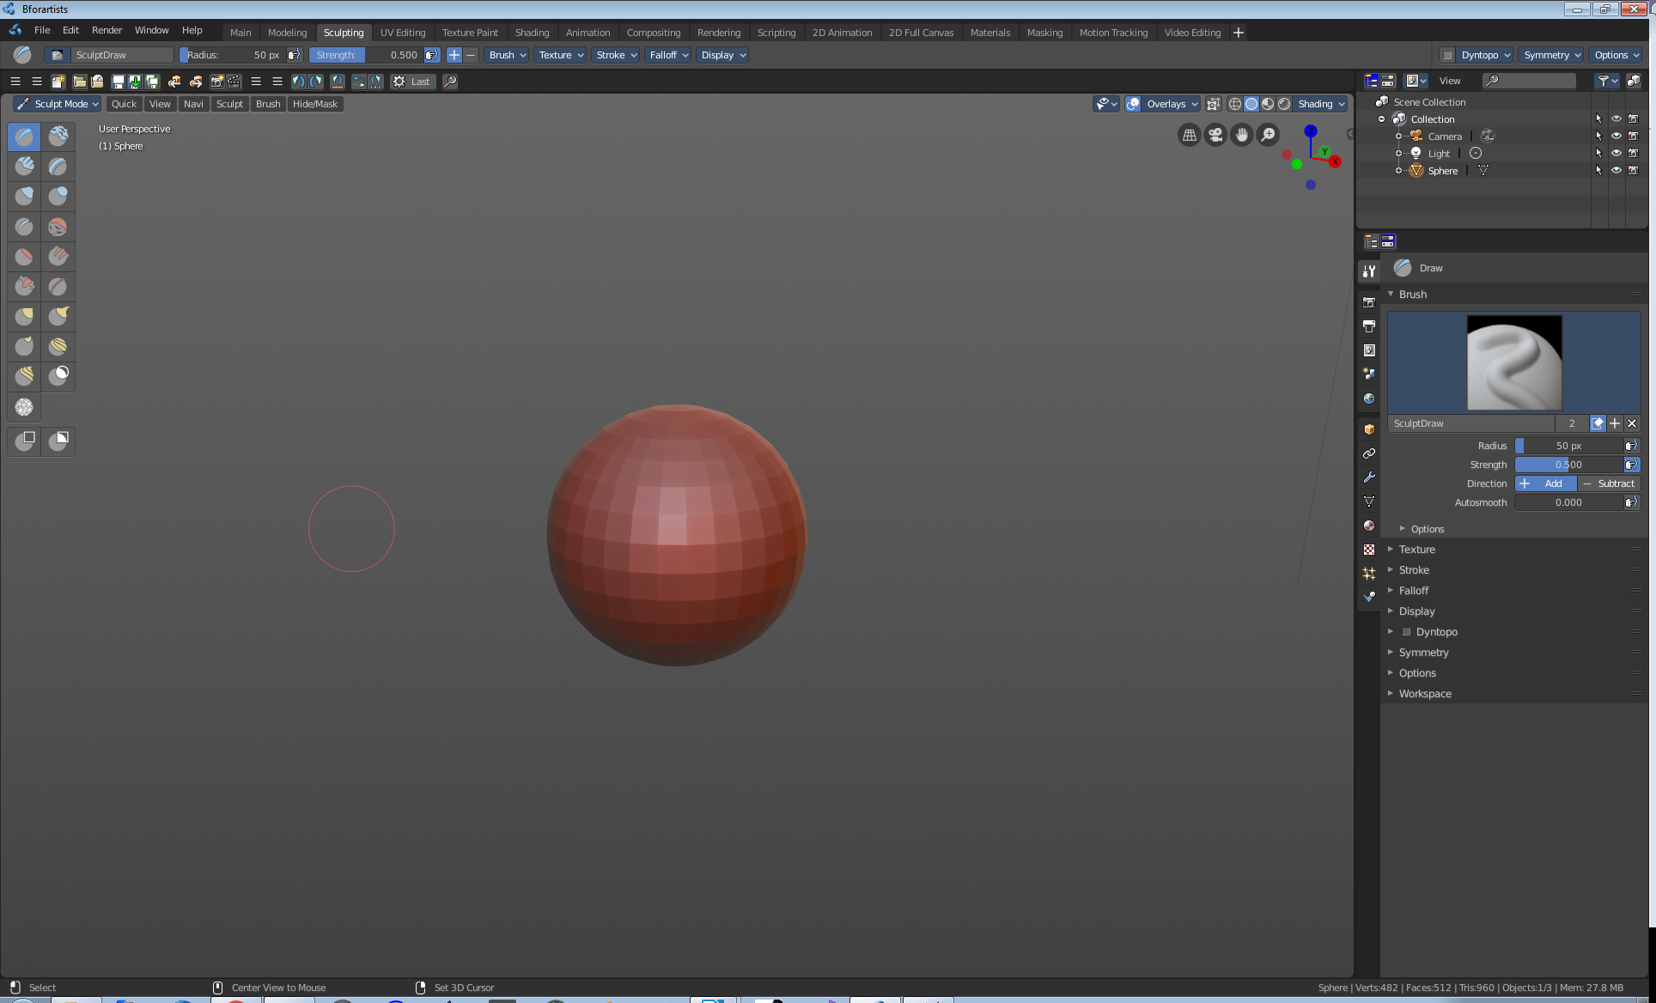

UV Editing  The UV Editing ist made for texturing and UV mapping. It contains a Info Editor, a UV Editor and a 3D View editor.  The 3D View starts in Edit mode. | 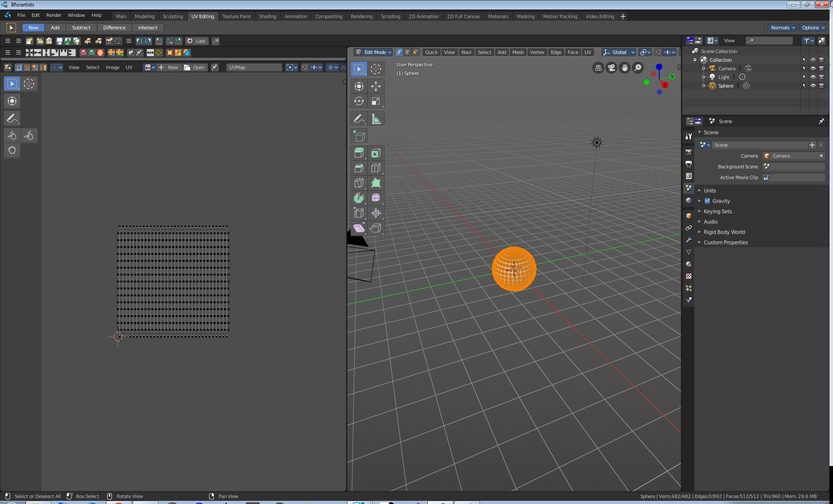

Texture Painting  Here you can do texture painting work. It contains a Info Editor, a Image Editor and a 3D View editor.  The 3D View starts in Edit mode. | 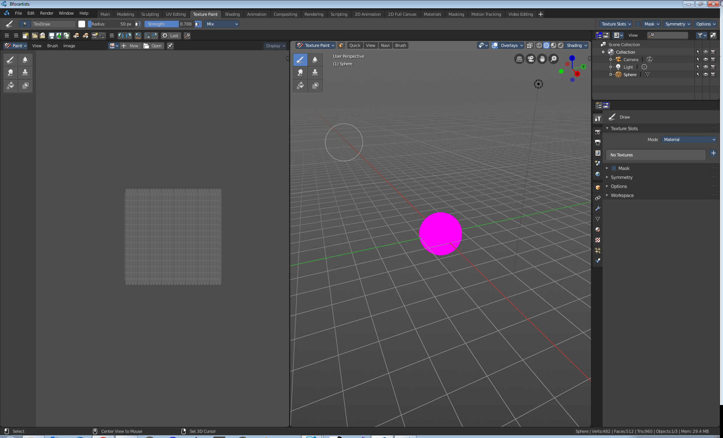

Shading  Here you can do all the shader and material work.  It comes with a file browser, a image editor, the 3D view in a special view look setup, the shader editor, outliner and properties editor. | 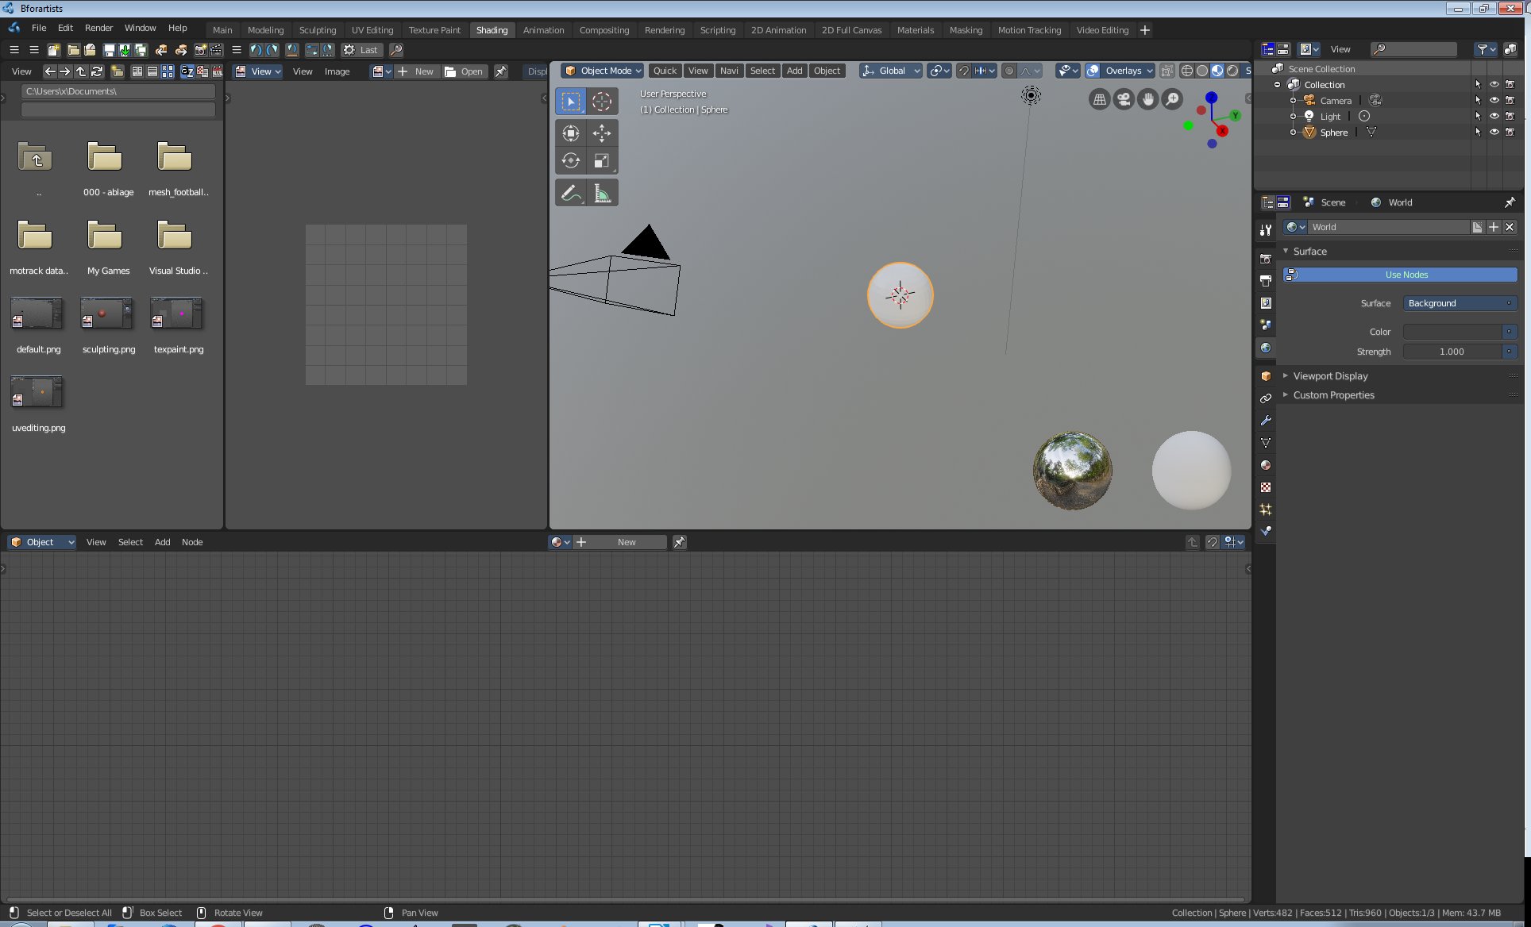

Animation  This workspace provides you with a layout that is optimized for Animation tasks. It contains two 3D View editors, a Info Editor, a Outliner Editor, a Properties Editor, a Timeline Editor, a Dope Sheet Editor. | 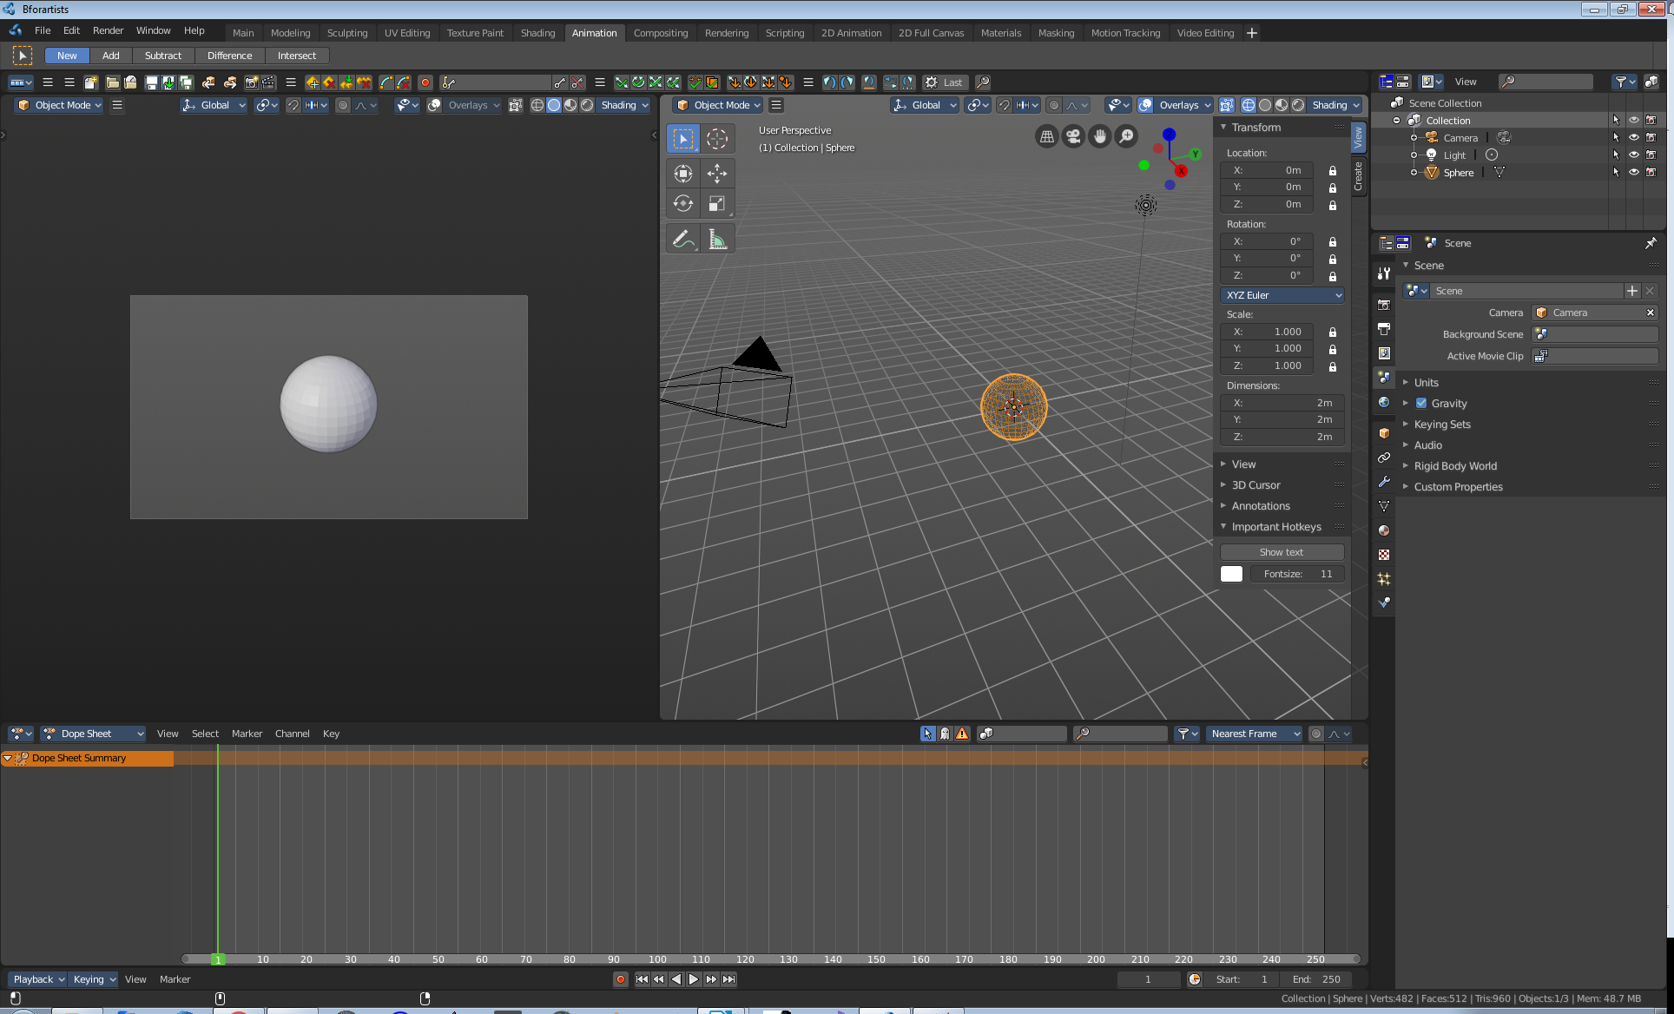

Compositing  Here you can do compositing and post processing. | 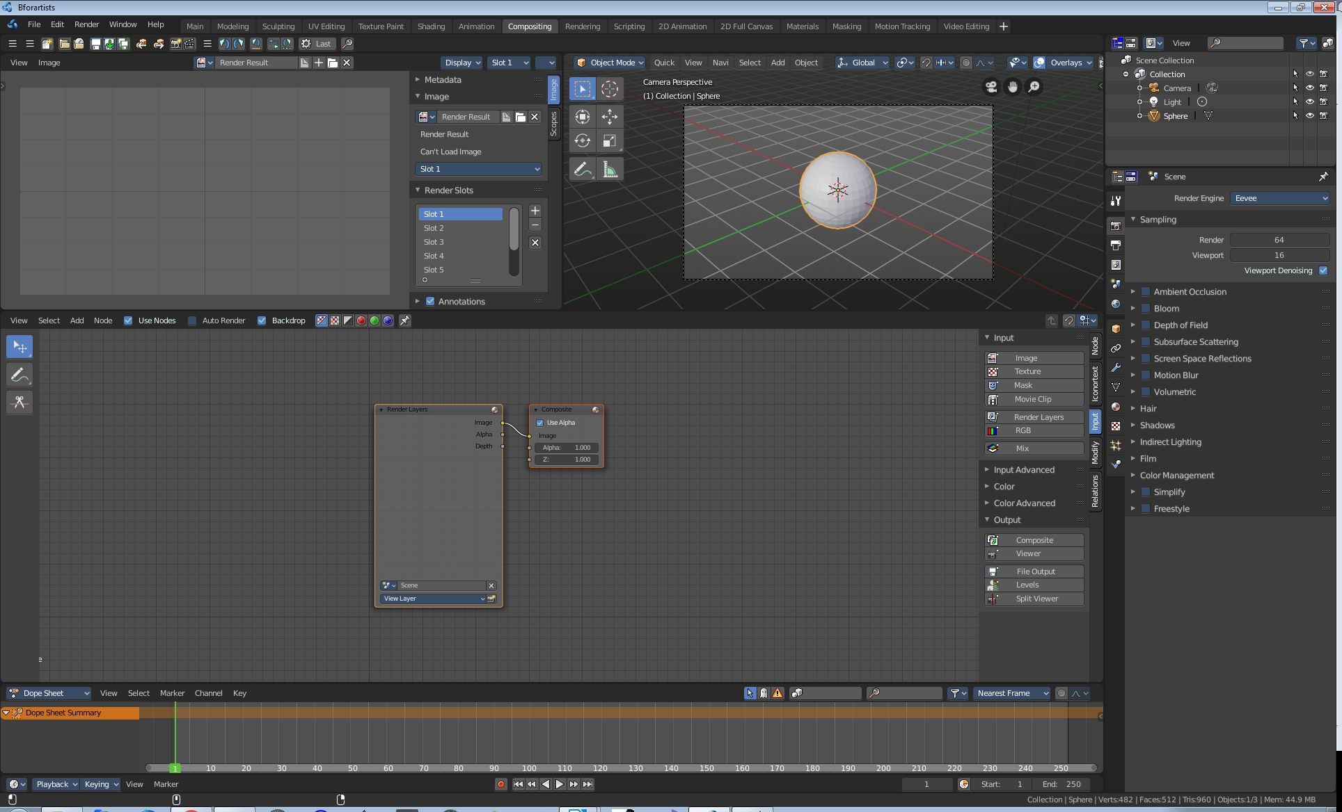

Rendering  A workspace for the rendering. | 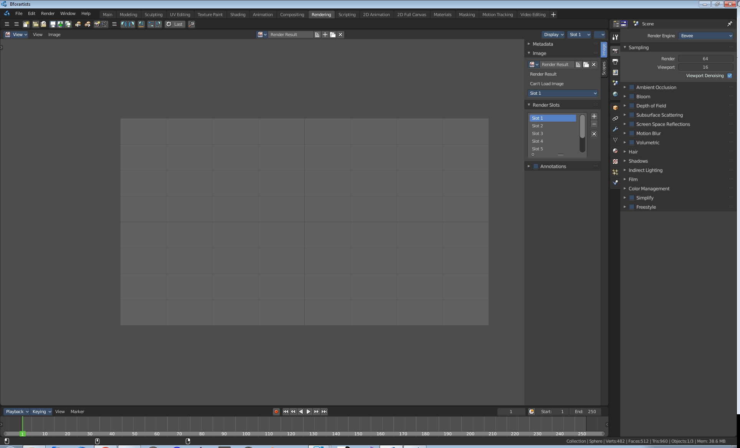

Scripting  The scripting workspace gives you a layout where you can write Python code. It contains a Info editor, a 3D View editor, a Console editor, a Text editor, a Outliner Editor and a Properties Editor. | 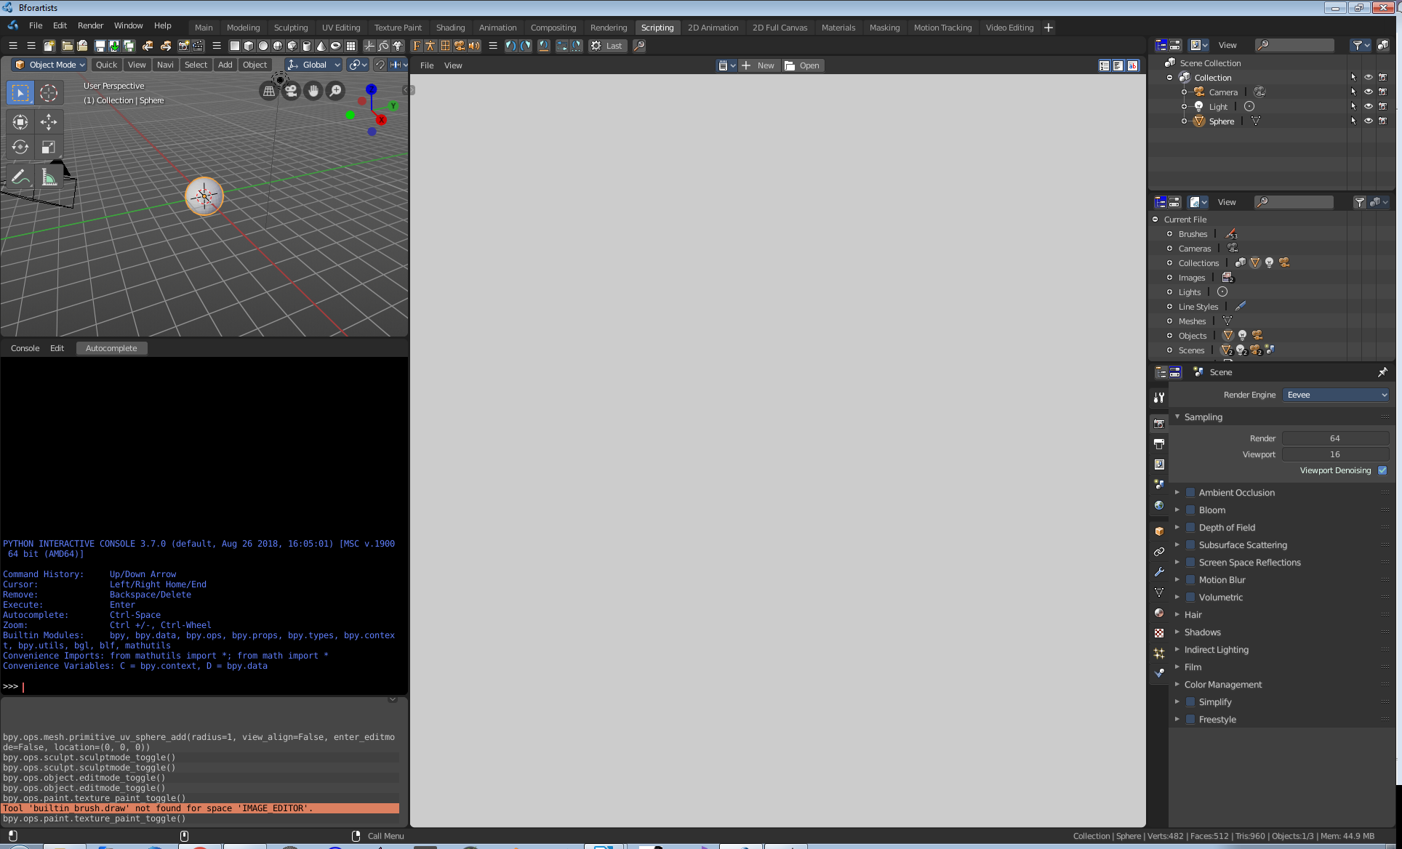

2D Animation  A workspace to work with the grease pencil and to create 2D animation. | 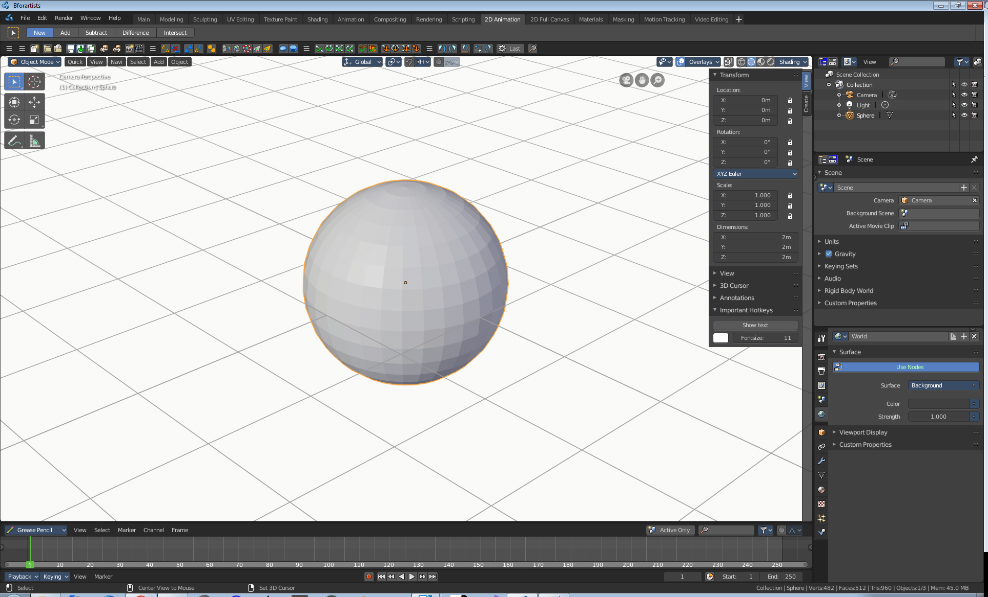

Full Canvas  A workspace to work with the grease pencil and to create 2D animation. The 3D view is maximized. | 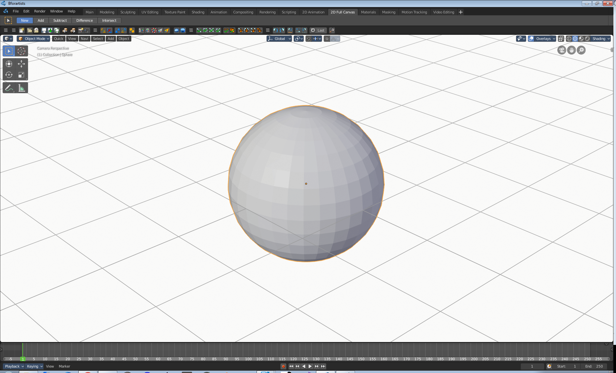

Material  Here you can do all the shader and material work.  It comes with a file browser, a image editor, the 3D view in a special view look setup, the shader editor, outliner and properties editor. | 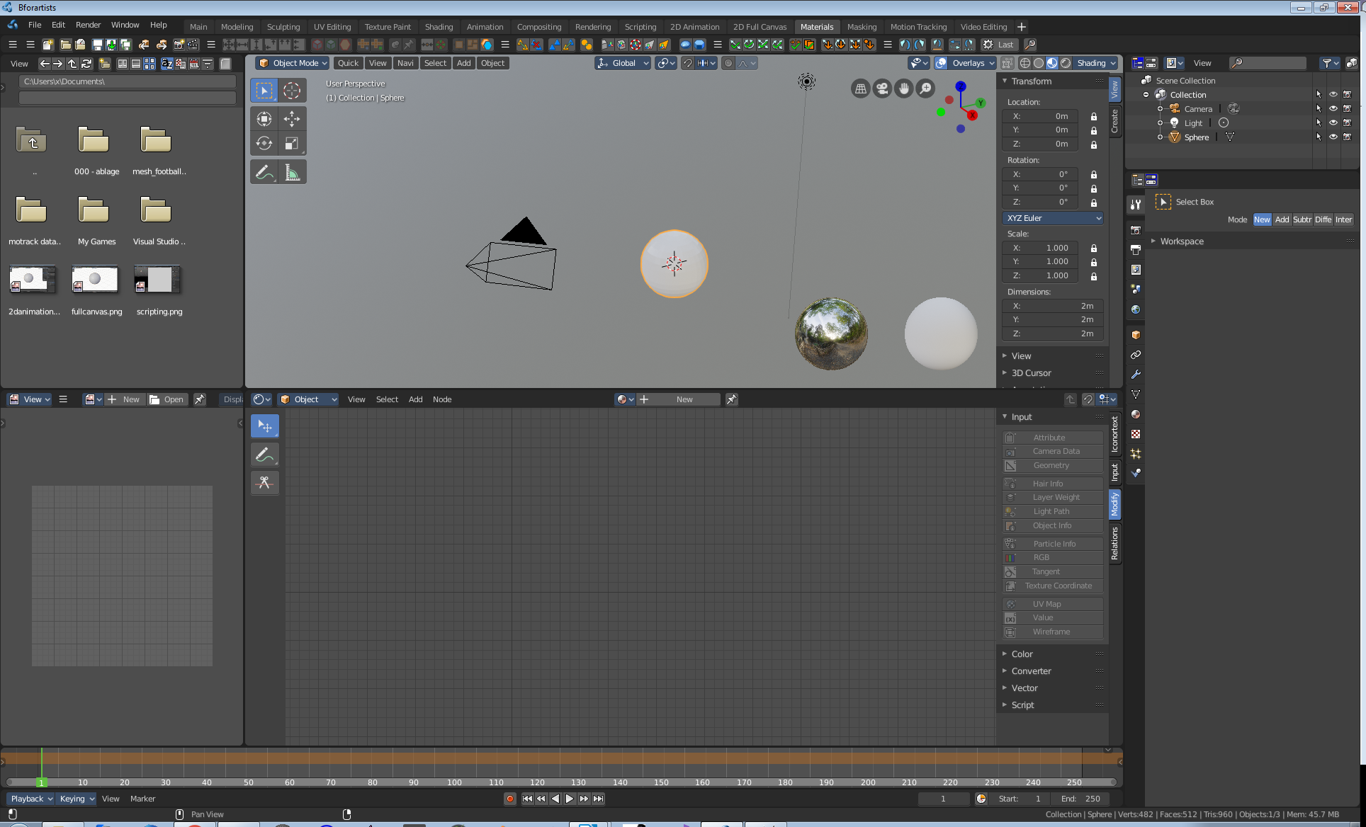

Masking  A workspace for the VFX workflow, to mask content. | 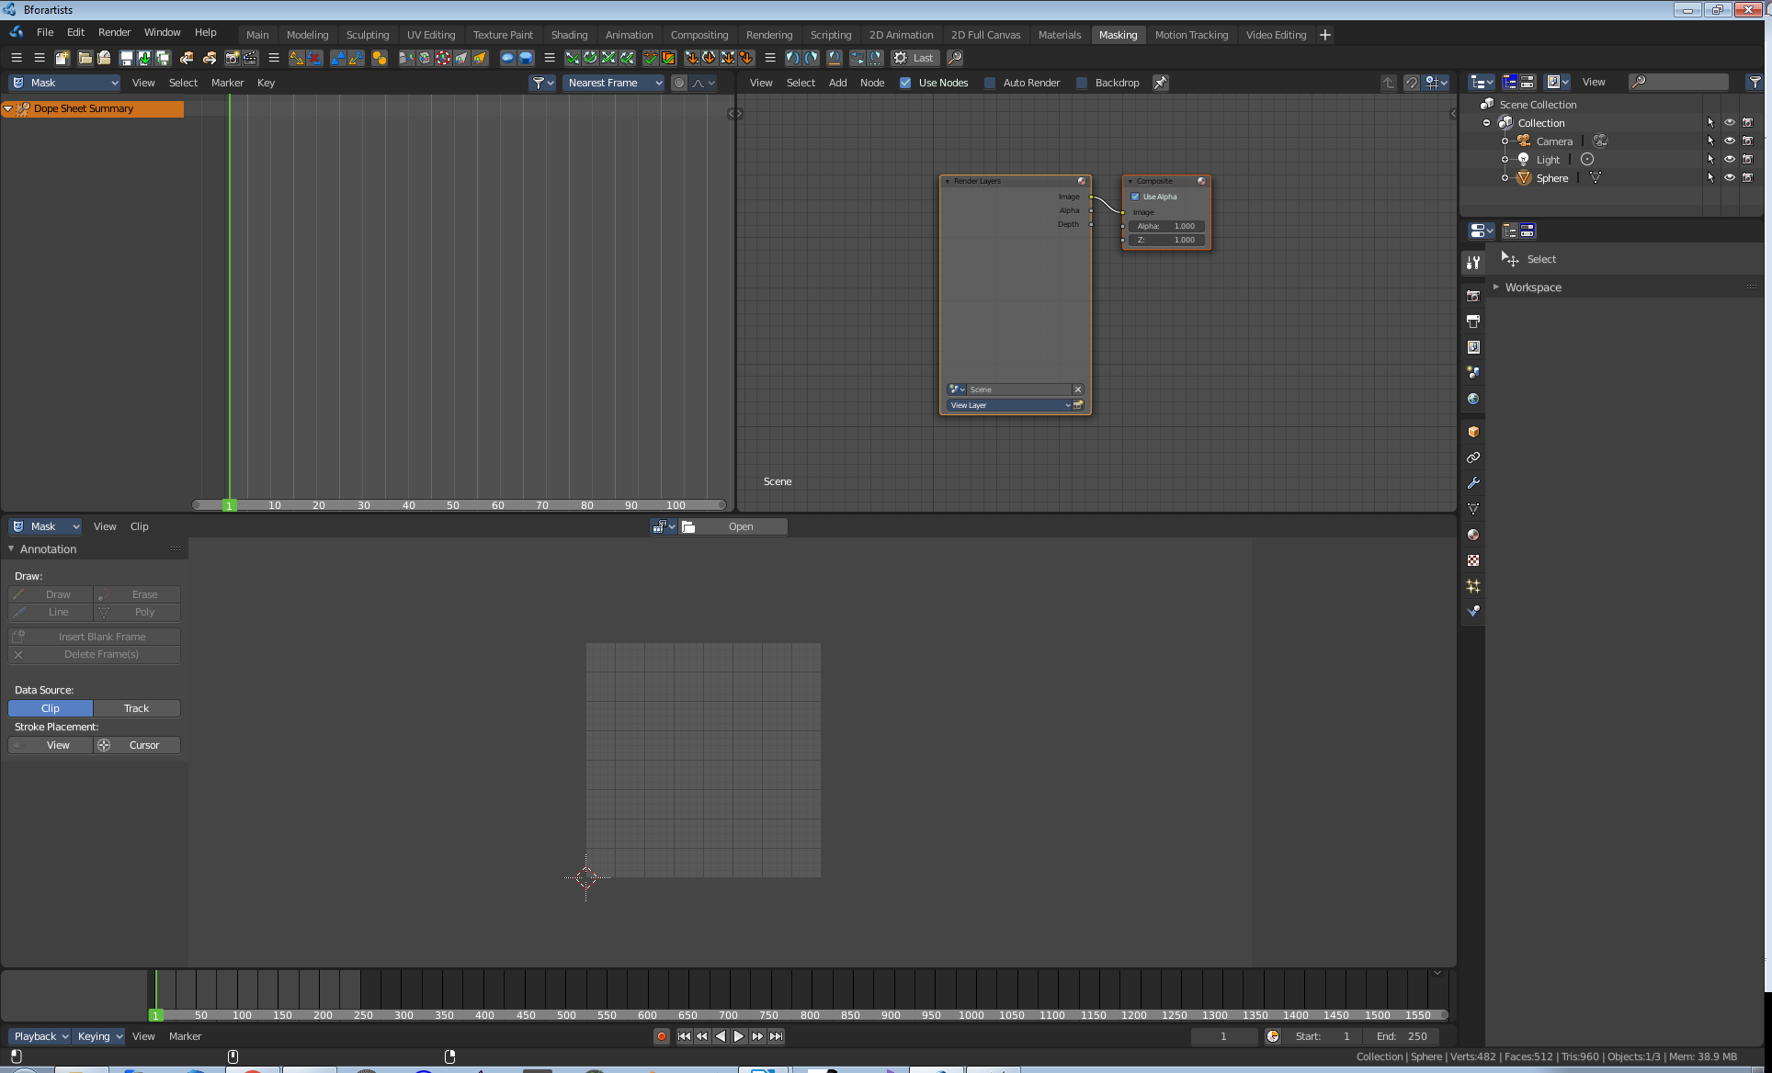

Masking
A workspace for the VFX workflow, to mask content.

Motion Tracking  A workspace for the VFX workflow. The Motion tracking layout. | 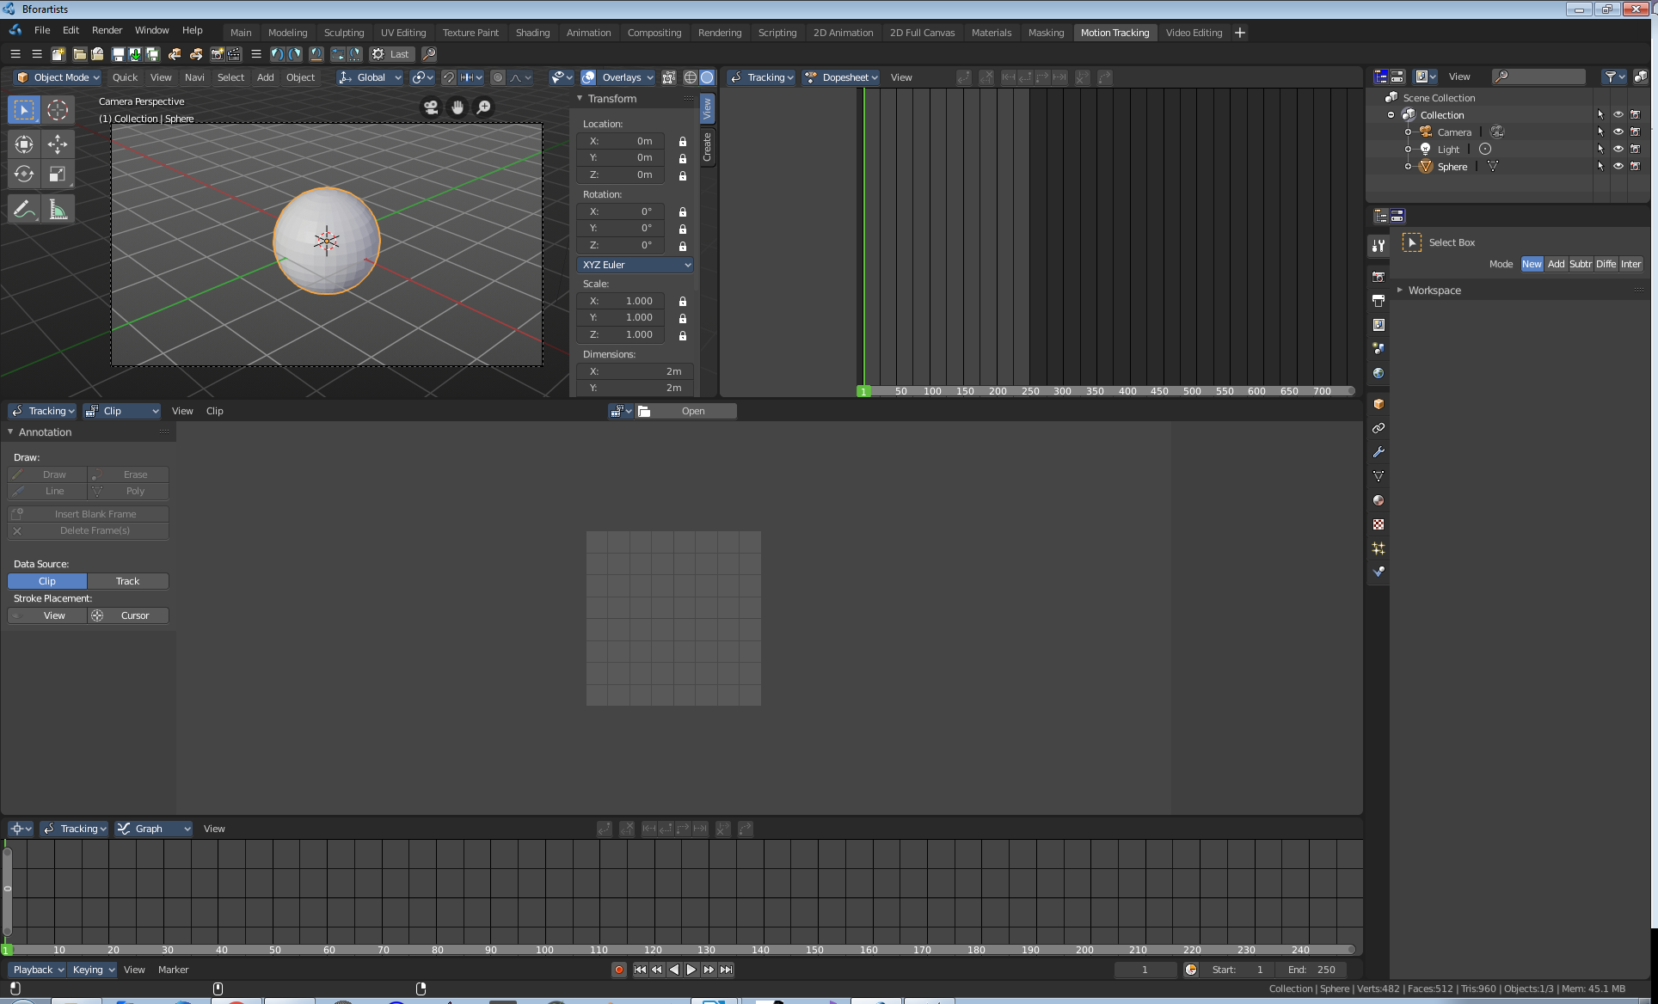

Video Editing  A workspace to edit videos. | 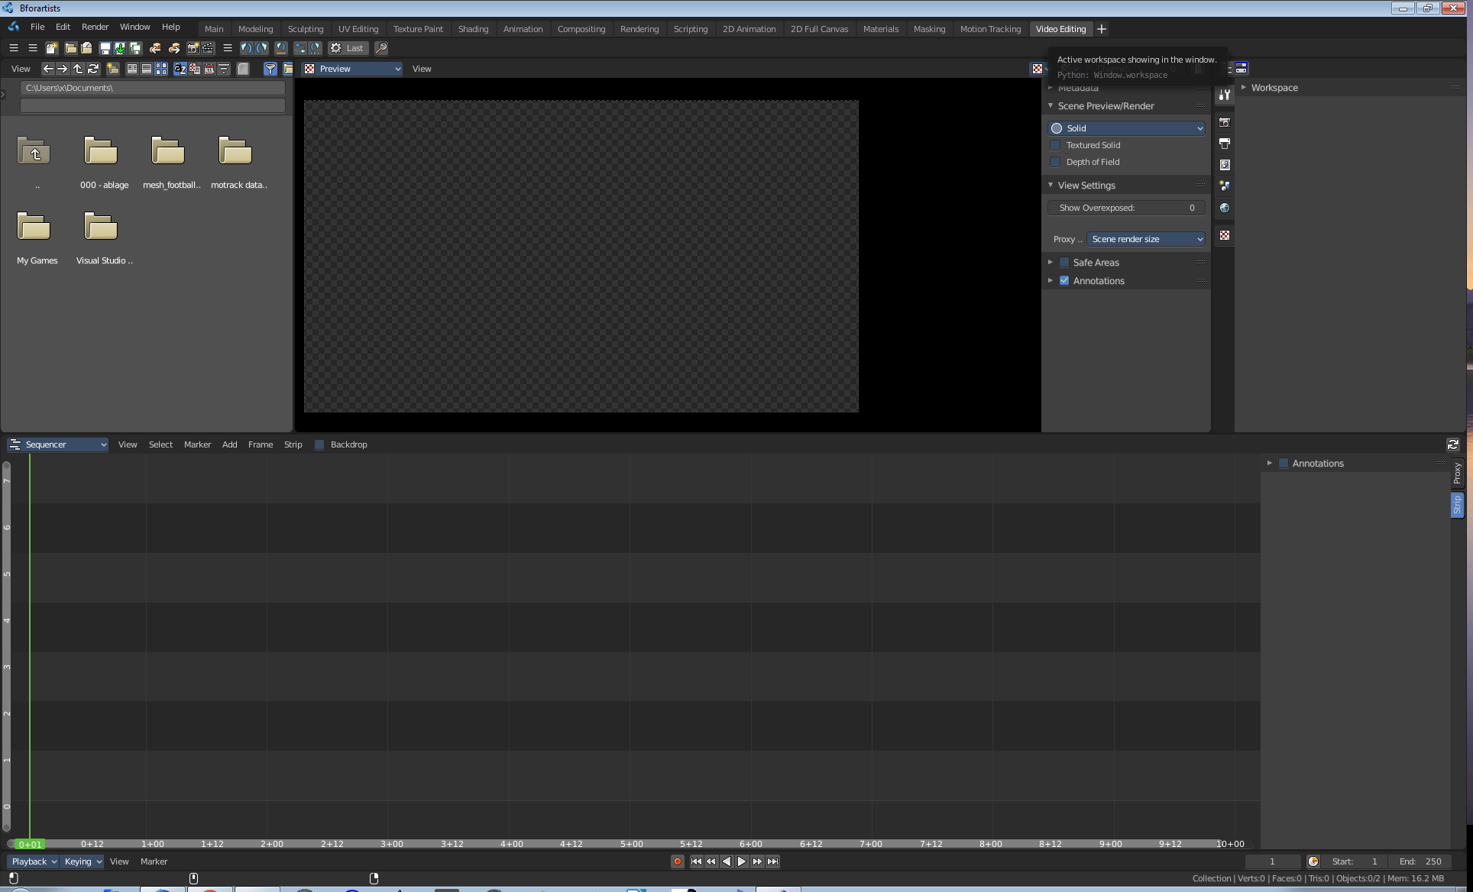

Footer

The footer displays some navigation functionality. And here you can find the scene information. In this area you will also see informations and warnings about the current operation. For example, you can see the progress bar for rendering here.

The Navigation content changes, dependant of where you have the mouse over.

Here you have the render status bar.

And the scene info changes, dependant if you are in object or edit mode. In Object Mode you have more general informations. In Edit mode you will see informations about the mesh.

